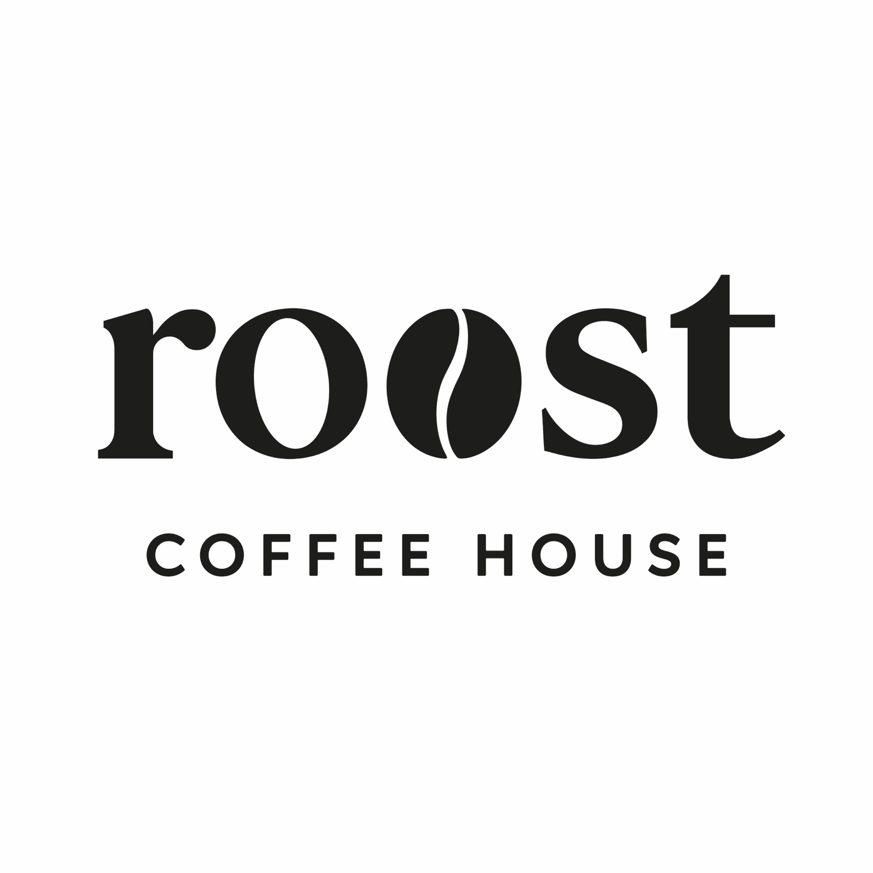

Supplier information, Ingredients and allergens
Contents

About this guide – Page 3

Suppliers contact details – Page 4

The Dessert Company – Pages 5-11

Stir Bakery Page – Pages 12- 13

Country Kitchen - Page 14

Silver Oak – Page 15

Cambridge Juice Company - Page 16-17

Bespoke Bakes – Page 18-19

Procopios Pantry – Page 21

Staff declarations – Page 22 onwards

Ingredients & Allergen Information Guide
Staff Briefing & Usage Guidance
This guide has been produced to ensure Roost Coffee House meets its legal obligations under UK food safety and food information legislation and to protect customers with food allergies or intolerances. Allergens can cause serious, and sometimes life-threatening, reactions. Accurate communication of allergen information is therefore essential.

Purpose of This Guide
This document contains supplier information, ingredient lists, allergen identification (including the 14 legally recognised allergens), and “may contain” or cross-contamination details for food and drink served at Roost. It must be used by all staff involved in food preparation and customer service.

Legal Duty
Roost is legally required to provide clear, accurate, and consistent allergen information to customers.
Staff must:
- Never guess allergen or ingredient information
- Always refer to this guide when responding to customer queries
- Ensure information given to customers matches this document
If information cannot be confirmed, a manager must be consulted before responding.

Using This Guide
- Check this guide whenever a customer asks about ingredients or allergens
- Do not rely on memory or assumptions
- Escalate any uncertainty immediately
- Report any product, recipe, or supplier changes so the guide can be updated

Communication with Customers
All allergen queries must be taken seriously.
Staff should:
- Clarify allergies vs intolerances where appropriate
- Clearly explain any “may contain” or cross-contamination risks
- Never make guarantees unless confirmed in this guide

Cross-Contamination
Roost handles allergens within the premises. While procedures are in place to reduce risk, cross-contamination may occur. Any relevant risk information listed in this guide must be communicated to customers.

Staff Responsibility
All staff are responsible for understanding how to access and use this guide, completing allergen training, and escalating concerns when unsure. Customer safety is a shared responsibility.
Supplier contact details
The Dessert Company – Cakes and sweet treats
01223 235522
info@thedessertcompany.co.uk
www.thedessertcompany.co.uk
Fareacres Farm, Dry Drayton Road, Oakington, Cambs, CB24 3BD
Main point of contact – Mark Lawson

Stir Bakery – Pastries and bread
01223 869944
orders@stirbakery.co.uk
www.stirbakery.co.uk
Main point of contact – Clare

Country Kitchen – Sausage Rolls and Scotch Eggs
antoniailott@gmail.com
Main point of contact – Antonia ilott

Procopios Pantry – Scones
procopiospantry@gmail.com
Main point of contact - Peter

Stir Bakery

Pastries and Sweet Bakes
All Butter Croissant
Storage information – Store ambient on delivery day. Do not refrigerate.
Shelf life – Day of delivery only.
Ingredients – Wheat flour, butter (milk), water, yeast, sugar, salt.
Allergens – Wheat (gluten), milk.
May contain egg, soya, nuts, sesame.

Pain au Chocolat
Storage information – Store ambient on delivery day.
Shelf life – Day of delivery only.
Ingredients – Wheat flour, butter (milk), dark chocolate (cocoa mass, sugar, cocoa butter, soya lecithin), water, yeast, sugar, salt.
Allergens – Wheat (gluten), milk, soya.
May contain egg, nuts, sesame.

Pain Suisse
Storage information – Store ambient on delivery day.
Shelf life – Day of delivery only.
Ingredients – Wheat flour, butter (milk), custard (milk, egg, sugar, cornflour), chocolate, yeast, sugar, salt.
Allergens – Wheat (gluten), milk, egg, soya.
May contain nuts, sesame.

Spelt Banana Loaf Cake
Storage information – Store ambient in airtight container.
Shelf life – Up to 3 days from delivery.
Ingredients – Spelt flour (gluten), banana, egg, butter (milk), sugar, raising agents, spices.
Allergens – Spelt (gluten), egg, milk.
May contain nuts, soya.

Cinnamon Knots
Storage information – Store ambient on delivery day.
Shelf life – Day of delivery only.
Ingredients – Wheat flour, butter (milk), sugar, cinnamon, yeast, salt.
Allergens – Wheat (gluten), milk.
May contain egg, nuts, sesame, soya.

Fruit Scone
Storage information – Store ambient in airtight container.
Shelf life – Up to 2 days from delivery.
Ingredients – Wheat flour, butter (milk), milk, dried fruit (sultanas), sugar, raising agents.
Allergens – Wheat (gluten), milk. May contain egg, nuts.

Cheese Scone
Storage information – Store ambient in airtight container.
Shelf life – Up to 2 days from delivery.
Ingredients – Wheat flour, cheddar cheese (milk), butter (milk), milk, raising agents.
Allergens – Wheat (gluten), milk.
May contain egg, mustard.

BREAD

Spelt Sourdough
Storage information – Store ambient. Do not refrigerate.
Shelf life – Up to 3 days from delivery.
Ingredients – Spelt flour (gluten), water, salt, sourdough starter.
Allergens – Spelt (gluten).
May contain sesame.

Focaccia Round
Storage information – Store ambient.
Shelf life – Day of delivery + 1 day.
Ingredients – Wheat flour, water, olive oil, yeast, salt, rosemary.
Allergens – Wheat (gluten).
May contain sesame.

Ciabatta Loaf
Storage information – Store ambient.
Shelf life – Day of delivery + 1 day.
Ingredients – Wheat flour, water, yeast, salt, olive oil.
Allergens – Wheat (gluten).
May contain sesame.

Gluten Free Sourdough – Seeded
Storage information – Store ambient, slice and toast recommended after day one.
Shelf life – Up to 3 days from delivery.
Ingredients – Gluten-free flour blend (rice, maize), water, seeds (sunflower, pumpkin, linseed), sourdough starter, salt.
Allergens – Seeds.
Produced in a bakery handling gluten.

White & Wholemeal Sourdough
Storage information – Store ambient.
Shelf life – Up to 3 days from delivery.
Ingredients – Wheat flour (white & wholemeal), water, salt, sourdough starter.
Allergens – Wheat (gluten).
May contain sesame.

Seed & Grain Sourdough
Storage information – Store ambient.
Shelf life – Up to 3 days from delivery.
Ingredients – Wheat flour, water, mixed seeds & grains (sesame, sunflower, linseed), salt, sourdough starter.
Allergens – Wheat (gluten), sesame.
May contain nuts.

Country Kitchen
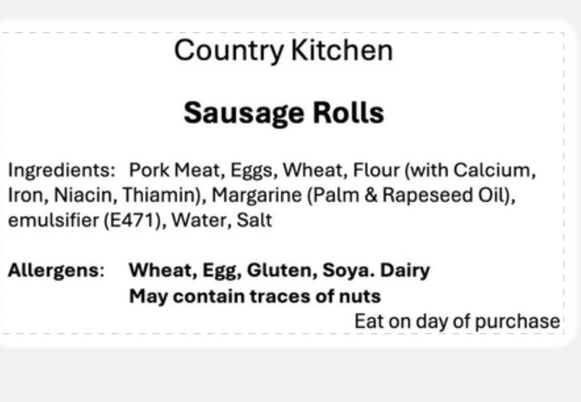

Sausage Roll

Storage information -

Shelf life – 5 days

Ingredients –

Allergens -
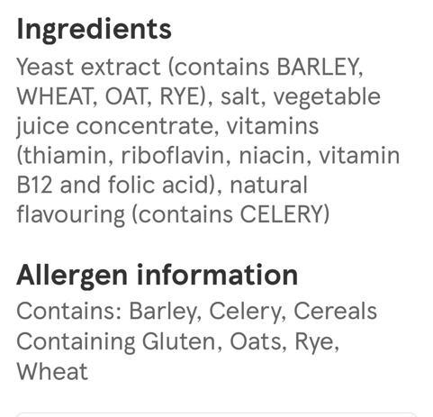
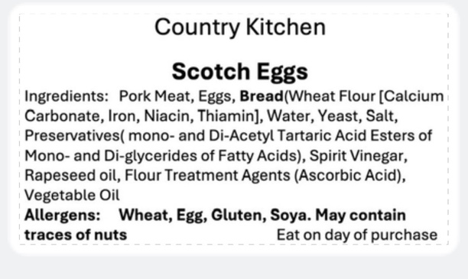

Scotch Egg

Storage information -

Shelf life – 5 days

Ingredients –

Allergens -

Brie & Bacon Sausage roll

Allergens: Gluten (Wheat), Milk, Egg, Soya

May contain: unless stated, all products may contain peanuts and tree nuts (cashew nuts and pine

Silver Oak

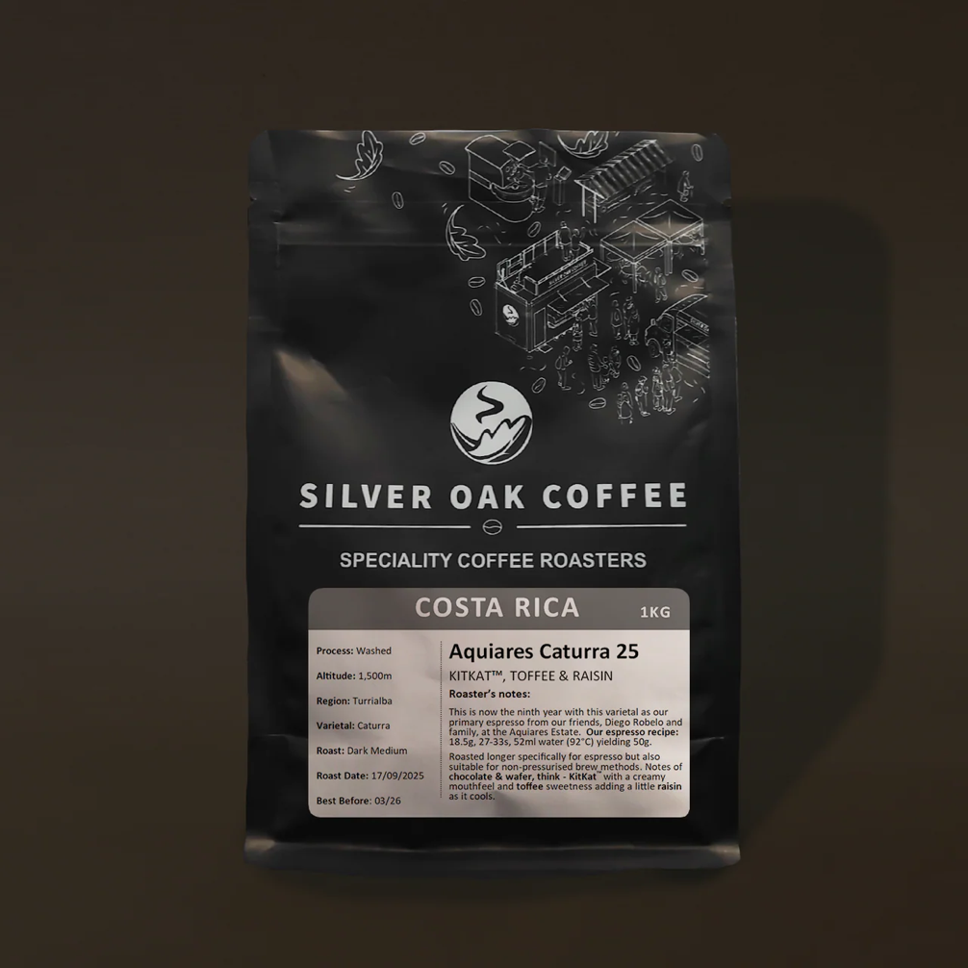

This is now the ninth year with our primary espresso from our friends, Diego Robelo and family, at the Aquiares Estate.
Roasted longer specifically for espresso but also suitable for non-pressurised brew methods.
Our espresso recipe: 18.5g, 27-33s, 52ml water (92°C) yielding 50g.

Cambridge Juice Company

Glebe Farm Pureoaty Barista Oat Milk
Nutritional Information
Per 100ml
- Energy 247 kJ 59 kcal
- Fat 1.8g Of which saturated 0.2g
- Carbohydrate 9.9g Of which Sugars 3.9g
- Fibre <0g
- Protein 1.1g
- Salt 0.1g
Ingredients
Water GLUTEN Free OATS (11% ) Sunflower Oil Salt

Glebe Farm Barista Almond Milk
Nutritional Information
- Energy 259 kJ 62 kcal
- Fat 1.8g Of which saturated 0.4g
- Carbohydrate 10.5g Of which Sugars 5.1g
- Fibre 0.5g
- Protein 0.8g
- Salt 0.1g
Ingredients:
Water, Almonds (4%), Maltodextrin (rice), Stabiliser (gellan gum), Natural Flavouring, Salt.
Nutritional Information Per 100ml
Energy 259 kJ
62 kcal
Fat 1.8g
of which saturates 0.4g
Carbohydrate 10.5g
of which sugars* 5.1g
Fibre 0.5g
Protein 0.8g
Salt 0.1g

Glebe Farm Barista Soya

Nutritional Information
- Energy 177 kJ 44 kcal
- Fat 1.5g Of which saturated 0.2g
- Carbohydrate 4.4g Of which Sugar 3.6g
- Fibre 0.6g
- Protein 3.0g
- Salt 0.1g
Ingredients:
Water, Dehulled Soya beans (7%), Sugar, Natural Flavouring, Stabiliser (Gellan Gum).
Nutritional Information Per 100ml
Energy 177 kJ
44 kcal
Fat 1.5g
of which saturates 0.2g
Carbohydrate 4.4g
of which sugars* 3.6g
Fibre 0.6g
Protein 3.0g
Salt 0.1g

Bespoke Bakes
Dishes and their allergen content
(Note – Please state the name of the cereal(s) containing gluten* and/or the name of the nut(s)†) All products are handled in a kitchen where nuts, gluten (wheat flour), soya, eggs and milk are present.

Dishes | Celery | Cereals containing gluten* | Crustaceans | Eggs | Fish | Lupin | Milk | Mollusc | Mustard | Nuts† | Peanuts | Sesame seeds | Soya | Sulphur Dioxide
Biscoff cookies |  | ✓Wheat flour |  | ✓ |  |  | ✓ |  |  |  |  |  | ✓
Kinder cookies |  | ✓Wheat flour |  | ✓ |  |  | ✓
White choc, macadamia, raspberry cookies |  | ✓Wheat flour |  | ✓ |  |  | ✓ |  |  | ✓Macadamia
Brown butter, salted caramel cookies |  | ✓Wheat flour |  | ✓ |  |  | ✓
Biscoff & Salted caramel cookie cup |  | ✓Wheat flour |  | ✓ |  |  | ✓ |  |  |  |  |  | ✓
Double choc cookie cup |  | ✓Wheat flour |  | ✓ |  |  | ✓
Classic brownie |  | ✓Wheat flour |  | ✓ |  |  | ✓
Triple choc brownie |  | ✓Wheat flour |  | ✓ |  |  | ✓
LG brownie |  |  |  | ✓ |  |  | ✓
Millionaires |  | ✓Wheat flour |  |  |  |  | ✓
LG millionaires |  |  |  |  |  |  | ✓
Hazelnut & salted caramel millionaires |  | ✓Wheat flour |  |  |  |  | ✓ |  |  | ✓Hazelnuts
Rocky road |  | ✓Wheat flour |  | ✓ |  |  | ✓ |  |  |  |  |  | ✓
Mini egg rocky road |  | ✓Wheat flour |  | ✓ |  |  | ✓ |  |  |  |  |  | ✓
Kinder cookies |  | ✓Wheat flour |  | ✓ |  |  | ✓ |  |  | ✓Hazelnuts |  |  | ✓
Biscoff & Salted caramel cookie cup |  | ✓Wheat flour |  | ✓ |  |  | ✓ |  |  |  |  |  | ✓
Millionaires |  | ✓Wheat flour |  |  |  |  | ✓ |  |  |  |  |  | ✓
Cornflake Brownie |  | ✓Wheat flour, Barley |  | ✓ |  |  | ✓ |  |  |  |  |  | ✓
Smarties cookie |  | ✓Wheat flour, Barley |  | ✓ |  |  | ✓ |  |  |  |  |  | ✓
Mars Brownie |  | ✓Wheat flour, Barley |  | ✓ |  |  | ✓ |  |  |  |  |  | ✓
Mars cookie brownie stack |  | ✓Wheat flour, Barley |  | ✓ |  |  | ✓ |  |  |  |  |  | ✓
Biscoff Brownie |  | ✓Wheat flour |  | ✓ |  |  | ✓ |  |  |  |  |  | ✓
Oreo Cookie |  | ✓Wheat flour |  | ✓ |  |  | ✓ |  |  |  |  |  | ✓
Salted Caramel Apple Cookie Slice |  | ✓Wheat flour |  | ✓ |  |  | ✓ |  |  |  |  |  | ✓
M&M monster cookie |  | ✓Wheat flour |  | ✓ |  |  | ✓ |  |  |  |  |  | ✓
Witches Brew Rocky road |  | ✓Wheat flour |  |  |  |  | ✓ |  |  |  |  |  | ✓

Review date:12/10/2026 |  | Reviewed by: | Amy Houghton |  |  |  | You can find this template, including more information at www.food.gov.uk/allergy-guidance

Product | Ingredients
Biscoff & Salted caramel Cookie cups | WHEAT FLOUR, light brown sugar, Butter (MILK), White chocolate (Sugar, cocoa butter, Whole MILK powder, emulsifier (SOYA lecithin) Natural vanilla flavouring), EGG, Biscoff spread (WHEAT FLOUR, sugar, vegetable oils (palm, rapeseed) candy sugar syrup, raising agent (sodium hydrogen carbonate) SOYA FLOUR, salt, cinnamon, rapeseed oil, sugar, emulsifier (SOYA lecithin) citric acid), Caramel (golden syrup, condensed milk (MILK), butter (MILK), sugar), cornflour, bicarbonate of soda, sea salt, Vanilla extract with seeds (water, vanilla extract, vanilla seeds, ethanol), sugar, inulin, thickener (tragacanth)
Millionaires’ shortbread | WHEAT FLOUR, sugar, Butter (MILK), Caramel (golden syrup, condensed milk (MILK), butter (MILK), sugar), Chocolate (Sugar, Whole MILK powder, Cocoa butter, cocoa mass, emulsifier lecithin (SOYA), Natural vanilla flavouring), Vanilla extract with seeds (water, vanilla extract, vanilla seeds, ethanol), sugar, inulin, thickener (tragacanth) CONTAINS: WHEAT, MILK, SOYA
Kinder cookies | WHEAT FLOUR, light brown sugar, Butter (MILK), Chocolate (Sugar, Whole MILK powder, Cocoa butter, cocoa mass, emulsifier lecithin (SOYA), Natural vanilla flavouring) HAZELNUT spread (sugar, palm oil, HAZELNUTS, fat reduced cocoa powder, dried skimmed milk (MILK), whey powder (MILK), lactose (MILK), emulsifier (sunflower lecithins) natural vanilla flavouring), Kinder bars (fine milk chocolate (MILK) (sugar, MILK powder, cocoa butter, cocoa mass, emulsifier :lecithin (SOYA), vanillin)sugar, skimmed MILK powder, palm oil, concentrated butter (MILK), emulsifier: lecithins (SOYA), vanillin, EGG, Vanilla extract with seeds (water, vanilla extract, vanilla seeds, ethanol), sugar, inulin, thickener (tragacanth)  CONTAINS: WHEAT, SOYA, EGG, MILK, HAZELNUTS
Cornflake Brownie | Sugar, Chocolate (cocoa mass, Sugar, cocoa butter, emulsifier lecithin (SOYA), Natural vanilla flavouring), butter (MILK), Cornflakes (Maize, sugar, salt, BARLEY malt extract, niacin, iron, pantothenic acid, vitamin B6, thiamin, riboflavin, folic acid, vitamin D, vitamin B12), Caramel (golden syrup, condensed milk (MILK), butter (MILK), sugar) EGG, WHEAT FLOUR, Cocoa powder (Acidity Regulator :501i, Citric acid), Vanilla extract with seeds (water, vanilla extract, vanilla seeds, ethanol), sugar, inulin, thickener (tragacanth) CONTAINS: WHEAT FLOUR, SOYA, BARLEY, EGG, MILK
Smarties cookie | WHEAT FLOUR, light brown sugar, Butter (MILK), Chocolate (Sugar, Whole MILK powder, Cocoa butter, cocoa mass, emulsifier lecithin (SOYA), Natural vanilla flavouring), smarties (sugar, skimmed milk powder (MILK), cocoa mass, glucose syrup, WHEAT FLOUR, whey powder product (MILK) butterfat (MILK), vegetable fats (palm, shea), starch, emulsifier (lecithins), colours (beetroot red, carotene, curcumin), flavourings, spirulina concentrate, glazing agents (carnauba wax, beeswax white), vegetable concentrates (safflower, radish), BARLEY malt extract), cornflour, EGG, Bicarbonate of soda, Vanilla extract with seeds (water, vanilla extract, vanilla seeds, ethanol), sugar, inulin, thickener (tragacanth) CONTAINS: MILK, SOYA, WHEAT, BARLEY, EGG
Salted Caramel Apple Cookie Slice | Sugar, Butter (MILK), Caramel (golden syrup, condensed milk (MILK), butter (MILK), sugar), WHEAT FLOUR, Chocolate (Sugar, Whole MILK powder, Cocoa butter, cocoa mass, emulsifier lecithin (SOYA), Natural vanilla flavouring), Apples, EGG, Bicarbonate of soda, Vanilla extract with seeds (water, vanilla extract, vanilla seeds, ethanol), sugar, inulin, thickener (tragacanth), Sea salt CONTAINS: WHEAT, EGG, MILK, SOYA
Mars Brownie | Sugar, Chocolate (cocoa mass, Sugar, cocoa butter, emulsifier lecithin (SOYA), Natural vanilla flavouring), butter (MILK), EGG, WHEAT FLOUR, Cocoa powder (Acidity Regulator :501i, Citric acid), Vanilla extract with seeds (water, vanilla extract, vanilla seeds, ethanol), sugar, inulin, thickener (tragacanth), Mars bars (Sugar, glucose syrup, skimmed MILK powder, cocoa butter, cocoa mass, sunflower oil, whey permeate (MILK), palm fat, MILK fat, fat-reduced cocoa powder, BARLEY malt extract, salt, emulsifier (SOYA lecithin), EGG white powder (MAY CONTAIN PEANUTS &amp; OTHER NUTS)) CONTAINS: WHEAT, SOYA, BARLEY, EGG, MILK
Biscoff Brownie | Chocolate (cocoa mass, Sugar, cocoa butter, emulsifier lecithin (SOYA), Natural vanilla flavouring), Sugar, Biscoff spread (WHEAT FLOUR, sugar, vegetable oils (palm, rapeseed) candy sugar syrup, raising agent (sodium hydrogen carbonate) SOYA FLOUR, salt, cinnamon, rapeseed oil, sugar, emulsifier (SOYA lecithin) citric acid), Caramelised biscuits (WHEAT FLOUR, sugar, palm oil, candy sugar syrup, rapeseed oil, raising agent: sodium carbonates, salt, ground cinnamon), butter (MILK), EGG, WHEAT FLOUR, Cocoa powder (Acidity Regulator :501i, Citric acid), Vanilla extract with seeds (water, vanilla extract, vanilla seeds, ethanol), sugar, inulin, thickener (tragacanth))  CONTAINS: WHEAT, SOYA, EGG, MILK
Mars cookie & Brownie stack | Sugar, Chocolate (cocoa mass, Sugar, cocoa butter, emulsifier lecithin (SOYA), Natural vanilla flavouring), butter (MILK), Mars bars (Sugar, glucose syrup, skimmed MILK powder, cocoa butter, cocoa mass, sunflower oil, whey permeate (MILK), palm fat, MILK fat, fat-reduced cocoa powder, BARLEY malt extract, salt, emulsifier (SOYA lecithin), EGG white powder (MAY CONTAIN PEANUTS &amp; OTHER NUTS)), Milk chocolate spread ( Sugar, vegetable oil (rapeseed, palm), Lactose (MILK), milk chocolate crumb (MILK, sugar, cocoa mass), full cream MILK powder, fat reduced cocoa, whey powder (MILK), emulsifier: lecithin,flavouring), EGG, WHEAT FLOUR, Cocoa powder (Acidity Regulator :501i, Citric acid), Vanilla extract with seeds (water, vanilla extract, vanilla seeds, ethanol), sugar, inulin, thickener (tragacanth) CONTAINS: WHEAT, SOYA, BARLEY, EGG, MILK
Oreo Cookie | WHEAT FLOUR, light brown sugar, Butter (MILK), Chocolate (Sugar, Whole MILK powder, Cocoa butter, cocoa mass, emulsifier lecithin (SOYA), Natural vanilla flavouring), Oreos (WHEAT flour, sugar, palm oil, rapeseed oil, WHEAT starch, fat reduced cocoa powder, glucose- fructose syrup, raising agent (ammonium carbonates, potassium carbonates, sodium carbonates), salt, emulsifier (SOYA lecithins), acidity regulator (sodium hydroxide), flavouring)), cornflour, EGG, Bicarbonate of soda, Vanilla extract with seeds (water, vanilla extract, vanilla seeds, ethanol), sugar, inulin, thickener (tragacanth) CONTAINS: MILK, SOYA, WHEAT, EGG
Witches brew rocky road | Chocolate (cocoa mass, Sugar, cocoa butter, emulsifier lecithin (SOYA), Natural vanilla flavouring), Digestives (WHEAT FLOUR (calcium carbonate, Iron, Niacin, Thiamin), Palm oil, wholemeal WHEAT FLOUR, sugar, rapeseed oil, partially inverted sugar syrup, Raising agents (sodium bicarbonate, ammonium hydrogen carbonate), salt), Mini marshmallows (Glucose syrup, sugar, Dextrose, water, humectant: orbital syrup, gelatine, fruit and plant concentrates: beetroot safflower, flavouring), Oreos (WHEAT flour, sugar, palm oil, rapeseed oil, WHEAT starch, fat reduced cocoa powder, glucose- fructose syrup, raising agent (ammonium carbonates, potassium carbonates, sodium carbonates), salt, emulsifier (SOYA lecithin), acidity regulator (sodium hydroxide), flavouring)), Sweets (Glucose syrup, sugar, gelatine, water, dextrose, acids (citric acid, lactic acid, malic acid, sodium malate), palm oil, flavourings, modified starch (WHEAT, maize, potato), fruit and vegetable juice concentrates (apple, radish, blackcurrant, black carrot), colouring food (black carrot concentrate), Glazing agents (carnauba wax, beeswax, palm oil, colours (E100, E102, E110, E120, E129, E133,E141, E150c, E153, E161b, E160c), butter (MILK), Golden syrup (Partially inverted refiners syrup) CONTAINS: WHEAT, SOYA, MILK
M&M monster cookie | WHEAT FLOUR, light brown sugar, Butter (MILK), M&Ms (Sugar, cocoa mass, skimmed MILK powder, cocoa butter, LACTOSE, starch, MILK fat, palm fat, glucose syrup, shea fat, stabiliser (gum arabic), dextrin, glazing agents (beeswax, carnauba wax), colours (E100, carmine, E132, E133, E150a, E150c, E150D, E153, E160a, E160e, E162, E163, E170), beetroot concentrate, emulsifiers (SOYA lecithin, E445), salt, flavourings, palm kernel oil, antioxidant (E306)). Chocolate (Sugar, Whole MILK powder, Cocoa butter, cocoa mass, emulsifier lecithin (SOYA), Natural vanilla flavouring), Cocoa powder (Acidity Regulator :501i, Citric acid), cornflour, EGG, Bicarbonate of soda, Sprinkles (Sugar, rice flour, sunflower oil, potato starch, colour (Radish, Blackcurrant, Apple, Safflower, Lemon, Spirulina, Carbon black (E153)), (Natural vanilla flavouring)), Edible eyes (Maltodextrin),Vanilla extract with seeds (water, vanilla extract, vanilla seeds, ethanol), sugar, inulin, thickener (tragacanth) CONTAINS: WHEAT, SOYA, EGG, MILK

Procopios Pantry

Fruit Scones

Self Raising Flour (GLUTEN)
Baking Powder
Baking Marge (RAPESEED)
Caster Sugar
Currants
EGGS
MILK

Cheese and Bacon

Self Raising Flour (GLUTEN)
Baking Powder
Salt
Pepper
Baking Marge (RAPESEED)
Bacon
Cheddar Cheese (MILK)
EGGS
MILK

Staff Allergen Awareness Declaration & Sign-Off
I confirm that I have read, understood, and agree to follow the Roost Coffee House Ingredients & Allergen Information Guide.
I understand that:
- I must not guess allergen or ingredient information
- I must always refer to the guide or a manager when responding to allergen queries
- Failure to follow allergen procedures may put customers at serious risk
I agree to follow allergen procedures at all times and to raise any concerns immediately.
Staff Name: _______________________________
Job Role: _______________________________
Signature: _______________________________
Date: _______________________________
Manager Signature: _______________________________

Staff Allergen Awareness Declaration & Sign-Off
I confirm that I have read, understood, and agree to follow the Roost Coffee House Ingredients & Allergen Information Guide.
I understand that:
- I must not guess allergen or ingredient information
- I must always refer to the guide or a manager when responding to allergen queries
- Failure to follow allergen procedures may put customers at serious risk
I agree to follow allergen procedures at all times and to raise any concerns immediately.
Staff Name: _______________________________
Job Role: _______________________________
Signature: _______________________________
Date: _______________________________
Manager Signature: _______________________________

Staff Allergen Awareness Declaration & Sign-Off
I confirm that I have read, understood, and agree to follow the Roost Coffee House Ingredients & Allergen Information Guide.
I understand that:
- I must not guess allergen or ingredient information
- I must always refer to the guide or a manager when responding to allergen queries
- Failure to follow allergen procedures may put customers at serious risk
I agree to follow allergen procedures at all times and to raise any concerns immediately.
Staff Name: _______________________________
Job Role: _______________________________
Signature: _______________________________
Date: _______________________________
Manager Signature: _______________________________

Staff Allergen Awareness Declaration & Sign-Off
I confirm that I have read, understood, and agree to follow the Roost Coffee House Ingredients & Allergen Information Guide.
I understand that:
- I must not guess allergen or ingredient information
- I must always refer to the guide or a manager when responding to allergen queries
- Failure to follow allergen procedures may put customers at serious risk
I agree to follow allergen procedures at all times and to raise any concerns immediately.
Staff Name: _______________________________
Job Role: _______________________________
Signature: _______________________________
Date: _______________________________
Manager Signature: _______________________________

Staff Allergen Awareness Declaration & Sign-Off
I confirm that I have read, understood, and agree to follow the Roost Coffee House Ingredients & Allergen Information Guide.
I understand that:
- I must not guess allergen or ingredient information
- I must always refer to the guide or a manager when responding to allergen queries
- Failure to follow allergen procedures may put customers at serious risk
I agree to follow allergen procedures at all times and to raise any concerns immediately.
Staff Name: _______________________________
Job Role: _______________________________
Signature: _______________________________
Date: _______________________________
Manager Signature: _______________________________

Staff Allergen Awareness Declaration & Sign-Off
I confirm that I have read, understood, and agree to follow the Roost Coffee House Ingredients & Allergen Information Guide.
I understand that:
- I must not guess allergen or ingredient information
- I must always refer to the guide or a manager when responding to allergen queries
- Failure to follow allergen procedures may put customers at serious risk
I agree to follow allergen procedures at all times and to raise any concerns immediately.
Staff Name: _______________________________
Job Role: _______________________________
Signature: _______________________________
Date: _______________________________
Manager Signature: _______________________________

Staff Allergen Awareness Declaration & Sign-Off
I confirm that I have read, understood, and agree to follow the Roost Coffee House Ingredients & Allergen Information Guide.
I understand that:
- I must not guess allergen or ingredient information
- I must always refer to the guide or a manager when responding to allergen queries
- Failure to follow allergen procedures may put customers at serious risk
I agree to follow allergen procedures at all times and to raise any concerns immediately.
Staff Name: _______________________________
Job Role: _______________________________
Signature: _______________________________
Date: _______________________________
Manager Signature: _______________________________

Staff Allergen Awareness Declaration & Sign-Off
I confirm that I have read, understood, and agree to follow the Roost Coffee House Ingredients & Allergen Information Guide.
I understand that:
- I must not guess allergen or ingredient information
- I must always refer to the guide or a manager when responding to allergen queries
- Failure to follow allergen procedures may put customers at serious risk
I agree to follow allergen procedures at all times and to raise any concerns immediately.
Staff Name: _______________________________
Job Role: _______________________________
Signature: _______________________________
Date: _______________________________
Manager Signature: _______________________________

