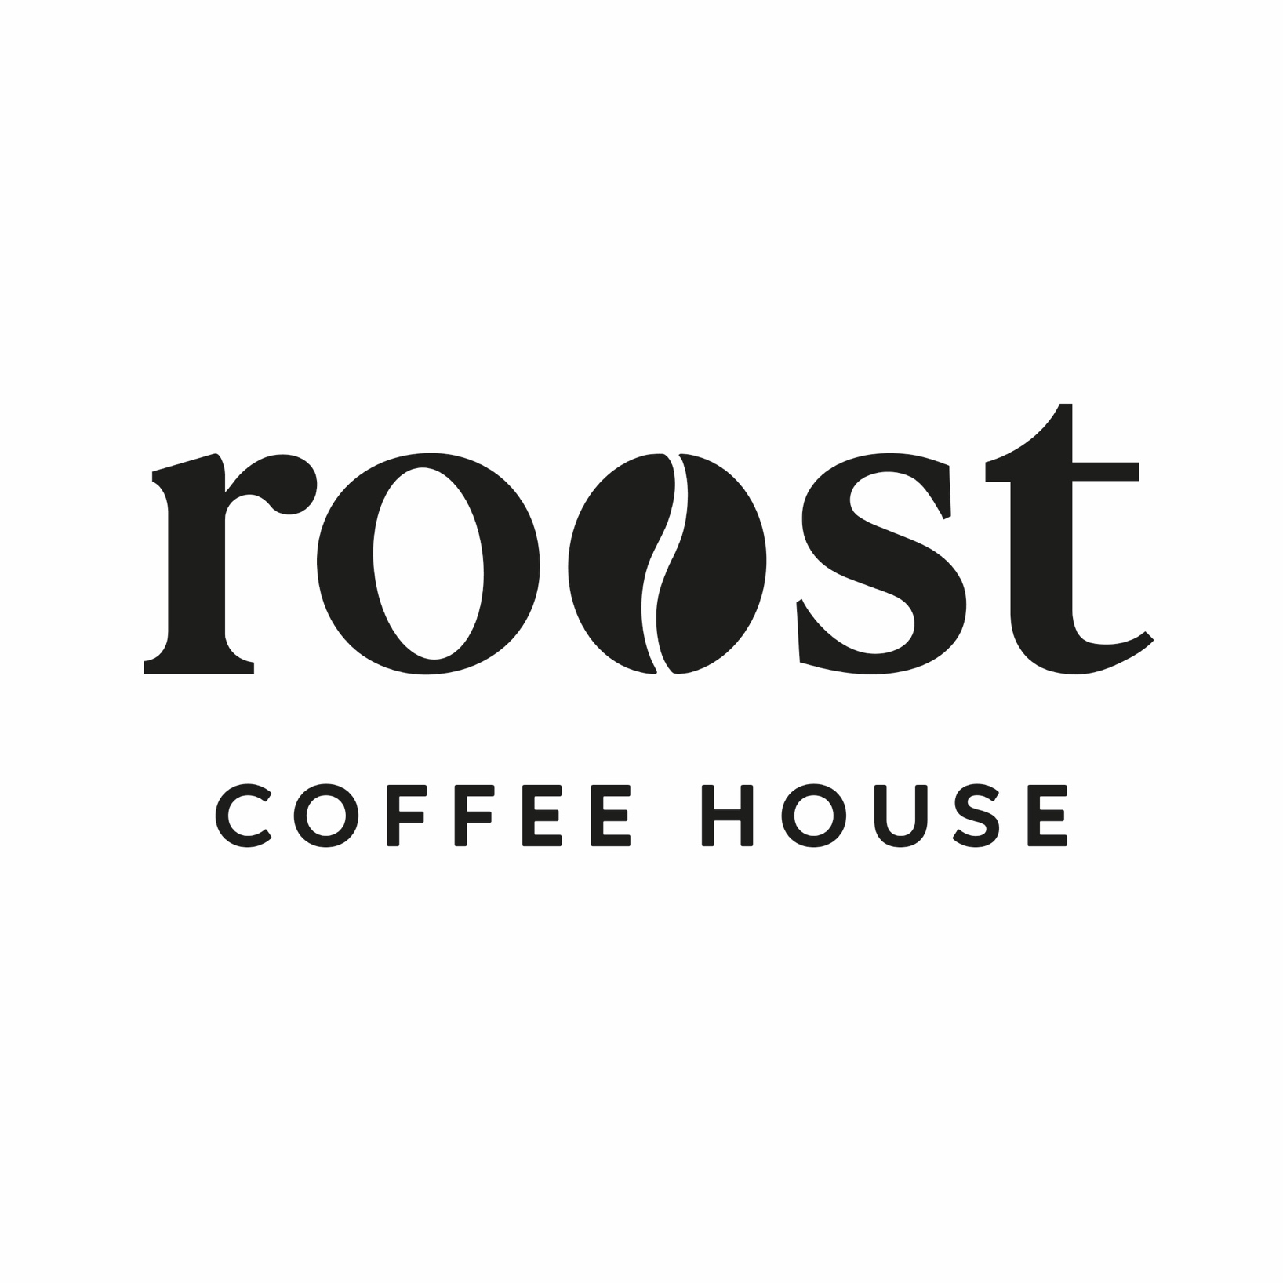

Supplier information, Ingredients and allergens
Contents

- About this guide – Page 3

- Supplier contact details – Page 4

- The Dessert Company – Pages 5-11

- Stir Bakery Page – Pages 12- 14

- Country Kitchen Page - 15

- Herbies – Page 16

- Silver Oak – Page 17

- Cambridge Juice Company - Page 18 - 19

- Staff declarations – Page 19 onwards

Ingredients & Allergen Information Guide
Staff Briefing & Usage Guidance
This guide has been produced to ensure Roost Coffee House meets its legal obligations under UK food safety and food information legislation and to protect customers with food allergies or intolerances. Allergens can cause serious, and sometimes life-threatening, reactions. Accurate communication of allergen information is therefore essential.

Purpose of This Guide
This document contains supplier information, ingredient lists, allergen identification (including the 14 legally recognised allergens), and “may contain” or cross-contamination details for food and drink served at Roost. It must be used by all staff involved in food preparation and customer service.

Legal Duty
Roost is legally required to provide clear, accurate, and consistent allergen information to customers.
Staff must:
- Never guess allergen or ingredient information
- Always refer to this guide when responding to customer queries
- Ensure information given to customers matches this document
If information cannot be confirmed, a manager must be consulted before responding.

Using This Guide
- Check this guide whenever a customer asks about ingredients or allergens
- Do not rely on memory or assumptions
- Escalate any uncertainty immediately
- Report any product, recipe, or supplier changes so the guide can be updated

Communication with Customers
All allergen queries must be taken seriously.
Staff should:
- Clarify allergies vs intolerances where appropriate
- Clearly explain any “may contain” or cross-contamination risks
- Never make guarantees unless confirmed in this guide

Cross-Contamination
Roost handles allergens within the premises. While procedures are in place to reduce risk, cross-contamination may occur. Any relevant risk information listed in this guide must be communicated to customers.

Staff Responsibility
All staff are responsible for understanding how to access and use this guide, completing allergen training, and escalating concerns when unsure. Customer safety is a shared responsibility.
Supplier contact details
The Dessert Company – Cakes and sweet treats
01223 235522
info@thedessertcompany.co.uk
www.thedessertcompany.co.uk
Fareacres Farm, Dry Drayton Road, Oakington, Cambs, CB24 3BD
Main point of contact – Mark Lawson

Stir Bakery – Pastries and bread
01223 869944
orders@stirbakery.co.uk
www.stirbakery.co.uk
Main point of contact – Clare

Country Kitchen – Sausage Rolls and Scotch Eggs
antoniailott@gmail.com
Main point of contact – Antonia ilott

Herbies American Diner – Cookies
01954 780001
Huntingdon Road, Swavesey, Cambridge, CB24 4RE
Paul.herbert11@btinternet.com
info@herbiesdiner.co.uk
Main point of contact – Paul and Claire

Stir Bakery

Pastries and Sweet Bakes
All Butter Croissant
Storage information – Store ambient on delivery day. Do not refrigerate.
Shelf life – Day of delivery only.
Ingredients – Wheat flour, butter (milk), water, yeast, sugar, salt.
Allergens – Wheat (gluten), milk.
May contain egg, soya, nuts, sesame.

Pain au Chocolat
Storage information – Store ambient on delivery day.
Shelf life – Day of delivery only.
Ingredients – Wheat flour, butter (milk), dark chocolate (cocoa mass, sugar, cocoa butter, soya lecithin), water, yeast, sugar, salt.
Allergens – Wheat (gluten), milk, soya.
May contain egg, nuts, sesame.

Pain Suisse
Storage information – Store ambient on delivery day.
Shelf life – Day of delivery only.
Ingredients – Wheat flour, butter (milk), custard (milk, egg, sugar, cornflour), chocolate, yeast, sugar, salt.
Allergens – Wheat (gluten), milk, egg, soya.
May contain nuts, sesame.

Spelt Banana Loaf Cake
Storage information – Store ambient in airtight container.
Shelf life – Up to 3 days from delivery.
Ingredients – Spelt flour (gluten), banana, egg, butter (milk), sugar, raising agents, spices.
Allergens – Spelt (gluten), egg, milk.
May contain nuts, soya.

Cinnamon Knots
Storage information – Store ambient on delivery day.
Shelf life – Day of delivery only.
Ingredients – Wheat flour, butter (milk), sugar, cinnamon, yeast, salt.
Allergens – Wheat (gluten), milk.
May contain egg, nuts, sesame, soya.

Fruit Scone
Storage information – Store ambient in airtight container.
Shelf life – Up to 2 days from delivery.
Ingredients – Wheat flour, butter (milk), milk, dried fruit (sultanas), sugar, raising agents.
Allergens – Wheat (gluten), milk. May contain egg, nuts.

Cheese Scone
Storage information – Store ambient in airtight container.
Shelf life – Up to 2 days from delivery.
Ingredients – Wheat flour, cheddar cheese (milk), butter (milk), milk, raising agents.
Allergens – Wheat (gluten), milk.
May contain egg, mustard.

BREAD

Spelt Sourdough
Storage information – Store ambient. Do not refrigerate.
Shelf life – Up to 3 days from delivery.
Ingredients – Spelt flour (gluten), water, salt, sourdough starter.
Allergens – Spelt (gluten).
May contain sesame.

Focaccia Round
Storage information – Store ambient.
Shelf life – Day of delivery + 1 day.
Ingredients – Wheat flour, water, olive oil, yeast, salt, rosemary.
Allergens – Wheat (gluten).
May contain sesame.

Ciabatta Loaf
Storage information – Store ambient.
Shelf life – Day of delivery + 1 day.
Ingredients – Wheat flour, water, yeast, salt, olive oil.
Allergens – Wheat (gluten).
May contain sesame.

Gluten Free Sourdough – Seeded
Storage information – Store ambient, slice and toast recommended after day one.
Shelf life – Up to 3 days from delivery.
Ingredients – Gluten-free flour blend (rice, maize), water, seeds (sunflower, pumpkin, linseed), sourdough starter, salt.
Allergens – Seeds.
Produced in a bakery handling gluten.

White & Wholemeal Sourdough
Storage information – Store ambient.
Shelf life – Up to 3 days from delivery.
Ingredients – Wheat flour (white & wholemeal), water, salt, sourdough starter.
Allergens – Wheat (gluten).
May contain sesame.

Seed & Grain Sourdough
Storage information – Store ambient.
Shelf life – Up to 3 days from delivery.
Ingredients – Wheat flour, water, mixed seeds & grains (sesame, sunflower, linseed), salt, sourdough starter.
Allergens – Wheat (gluten), sesame.
May contain nuts.

Country Kitchen
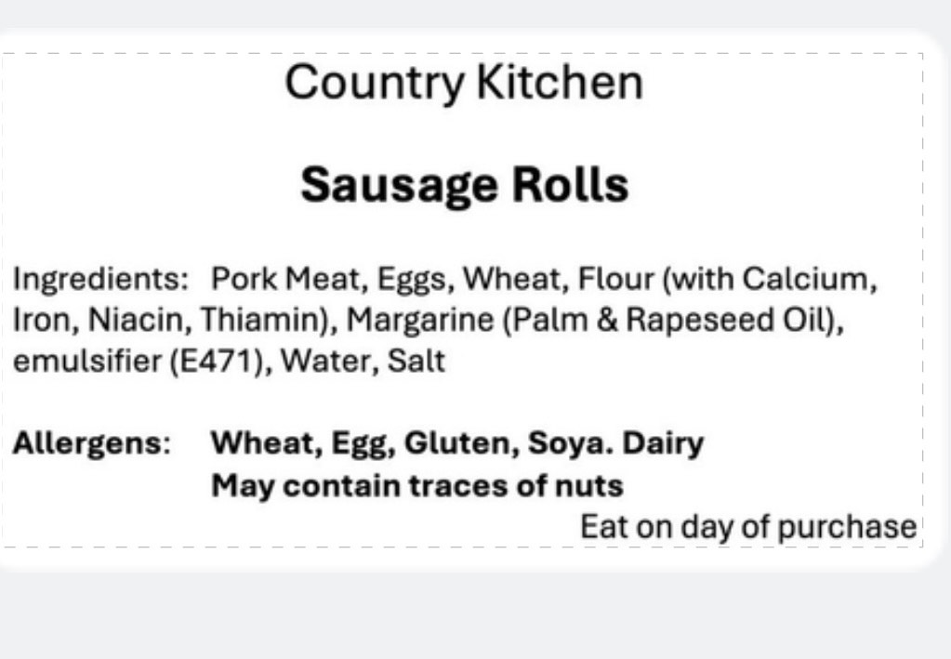

Sausage Roll

Storage information -

Shelf life – 5 days

Ingredients –

Allergens -
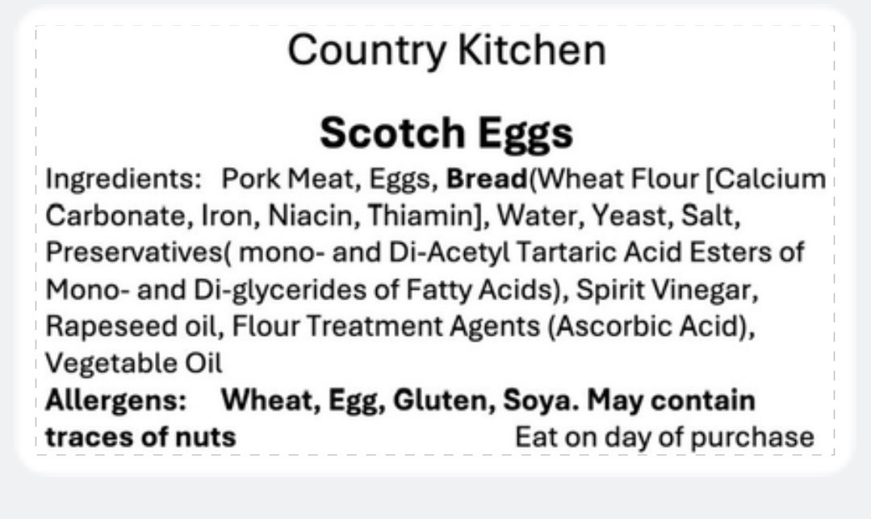

Scotch Egg

Storage information -

Shelf life – 5 days

Ingredients –

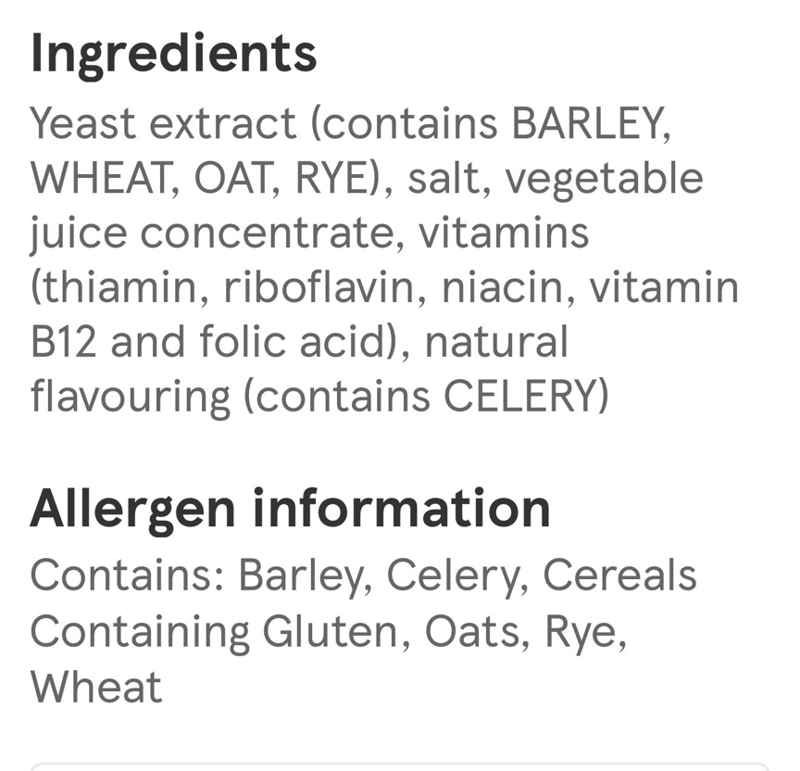
Allergens -

Herbies Bakes

Please note: We use gluten, eggs, dairy, soya, sesame, tree nuts & peanuts in our kitchen. Our products may not be suitable for allergy sufferers.
Gingerbread & White Chocolate Cookies
Baking butter: vegetable oils (rapeseed, palm), water, BUTTERMILK (7.5%), emulsifiers (sunflower lecithin, mono- & diglycerides of fatty acids) salt, natural flavouring (contain MILK) citric acid, vitamins (A,D), colour (carotenes). Light brown sugar (100% cane). EGGS. Vanilla essence: water, monopropylene glycol, colour (Caramel E150a), flavourings. Plain flour: (WHEAT flour, calcium, iron, niacin, nicotinamide, thiamin). Bicarbonate of soda: sodium hydrogen carbonate. Baking Powder: raising agents: diphosphates, sodium carbonates; rice flour. Ground Ginger. Ground Nutmeg. Ground Cinnamon. Salt: anti-caking agent (sodium hexacyanoferrate II). White Chocolate Chunks: sugar, cocoa butter, whole MILK powder, LACTOSE, Whey powder (MILK), emulsifier (SOYA) lecithin. May contain TREE NUTS & PEANUTS

Mince Pies
Pastry: Unsalted butter - minimum 82% MILK fat. Plain flour: (WHEAT flour, calcium, iron, niacin, nicotinamide, thiamin). Icing sugar: Anti-Caking Agent: Tricalcium Phosphate. EGG. Mincemeat: Dried Vine Fruits (32%) [Sultanas, Currants, Raisins], Apple Purée (21%), Sugar, Glucose-Fructose Syrup, Candied Mixed Citrus Peel (3%) [Orange Peel, Lemon Peel, Sugar], Rapeseed Oil, Spices, Preservative (Acetic Acid), Colour (Plain Caramel), Dill. May contain TREE NUTS & PEANUTS
(with crumble: unsalted butter - minimum 82% MILK fat. Plain flour: (WHEAT flour, calcium, iron, niacin, nicotinamide, thiamin). Caster sugar (cane 100%), Mixed Spice: Ground Cinnamon (Cassia) (40%), Ground Coriander (38%), Caraway Seed, Ground Nutmeg (4%), Ground Ginger, Cloves)

Nutella stuffed Chocolate Chip NYC Cookie
Baking butter: vegetable oils (rapeseed, palm), water, BUTTERMILK (7.5%), emulsifiers (sunflower lecithin, mono- & diglycerides of fatty acids) salt, natural flavouring (contain MILK) citric acid, vitamins (A,D), colour (carotenes). Light brown sugar (100% cane). Granulated white sugar (100% cane). EGGS. Vanilla essence: water, monopropylene glycol, colour (Caramel E150a), flavourings. Plain flour: (WHEAT flour, calcium, iron, niacin, nicotinamide, thiamin). Bicarbonate of soda: sodium hydrogen carbonate. Baking Powder: raising agents: diphosphates, sodium carbonates; rice flour. Milk Chocolate chunks: Sugar, whole (MILK) powder, cocoa butter, Cocoa mass, Whey powder (MILK) skimmed (MILK) powder, emulsifiers: (SOYA) lecithin, natural vanilla flavouring. Nutella spread: sugar, palm oil, HAZELNUTS (13%), Skimmed MILK powder (8.7%), fat reduced cocoa (7.4%), emulsifier: lecithins (SOYA), vanillin. Milk Chocolate: sugar, cocoa butter, whole MILK powder, cocoa mass, emulsifier (E322 (SOYA)), vanilla extract. Chopped Nuts: PEANUTS (70%), ALMONDS & WALNUTS. May contain other TREE NUTS.

Traditional Rocky Road
Milk Chocolate: sugar, cocoa butter, whole MILK powder, cocoa mass, emulsifier (E322 (SOYA)), vanilla extract. Golden syrup: partially inverted refiners syrup. Baking butter: vegetable oils (rapeseed, palm), water, BUTTERMILK (7.5%), emulsifiers (sunflower lecithin, mono- & diglycerides of fatty acids) salt, natural flavouring (contain MILK) citric acid, vitamins (A,D), colour (carotenes). Digestive biscuits: Wheat flour (WHEAT flour, calcium carbonate, iron, niacin, thiamine) wholemeal WHEAT flour, sugar, palm oil, rapeseed oil, OATS, partially inverted refiners syrup, raising agents (sodium bicarbonate, ammonium) salt. Marshmallows: Corn glucose fructose syrup, sugar water, pork gelatine, anti-caking agent (corn starch), colour (beetroot red), flavouring. WHEAT flour (WHEAT flour, calcium carbonate, iron, niacin, thiamine) Rapeseed oil, sugar, butter (MILK), salt, natural flavouring, raising agent (sodium carbonates). Raisins (99.9%), sunflower oil). Glace cherries: cherry (56%), glucose-frutose syrup, sugar (18%), acidity regulator (citric acid), preservatives (potassium sorbate, SULPHUR DIOXIDE), colour (Erythrosine). Milk Chocolate Spread: sugar, highly stable non-hydrogenated palm oleic fat, dry WHEY powder, fat-reduced cocoa powder (6%), skimmed MILK powder, emulsifier; E322 (SOYA lecithin), flavour (MILK). Milk Chocolate: sugar, cocoa butter, whole MILK powder, cocoa mass, emulsifier (E322 (SOYA)), vanilla extract. May contain TREE NUTS & PEANUTS

Smarties Cookies - Allergens in Bold

Baking butter: vegetable oils (rapeseed, palm), water, BUTTERMILK (7.5%), emulsifiers (sunflower lecithin, mono- & diglycerides of fatty acids) salt, natural flavouring (contain MILK) citric acid, vitamins (A,D), colour (carotenes). Caster sugar (100% cane). Light brown sugar (100% cane). EGGS. Vanilla essence: water, monopropylene glycol, colour (Caramel E150a), flavourings. Self raising flour: (WHEAT) flour (calcium carbonate, iron, nicotinamide, thiamine), raising agents (Monocalcium phosphate, sodium bicarbonate), Salt. Milk Chocolate chunks: Sugar, whole (MILK) powder, cocoa butter, Cocoa mass, Whey powder (MILK) skimmed (MILK) powder, emulsifiers: (SOYA) lecithin, natural vanilla flavouring. Mini Smarties: sugar, skimmed MILK powder, cocoa mass, cocoa butter, WHEAT flour, BUTTER oil, WHEY powder product, rice starch, emulsifier lecithins, colour (beetroot red,carotene, curcumin), spirulina concentrate, glazing agents (Caruba wax, beeswax white), vegetable concentrates (safflower, radish), BARLEY malt extract. Smarties: sugar, cocoa butter, skimmed MILK powder, cocoa mass, butterfat (from MILK), WHEAT flour, LACTOSE & proteins from whey (from MILK), rice starch, emulsifier: (lecithins), colours (beetroot red, carotene, curcumin), natural flavouring, spirulina concentrate, glazing agents (carnauba wax, beeswax white, fruit & vegetable concentrate (safflower, radish), BARLEY malt extract. White chocolate chunks: sugar cocoa butter, whole MILK powder, emulsifier (E322 sunflower lecithin), natural vanilla flavour, LACTOSE (May contain SOYA). May contain TREE NUTS & PEANUTS

Silver Oak

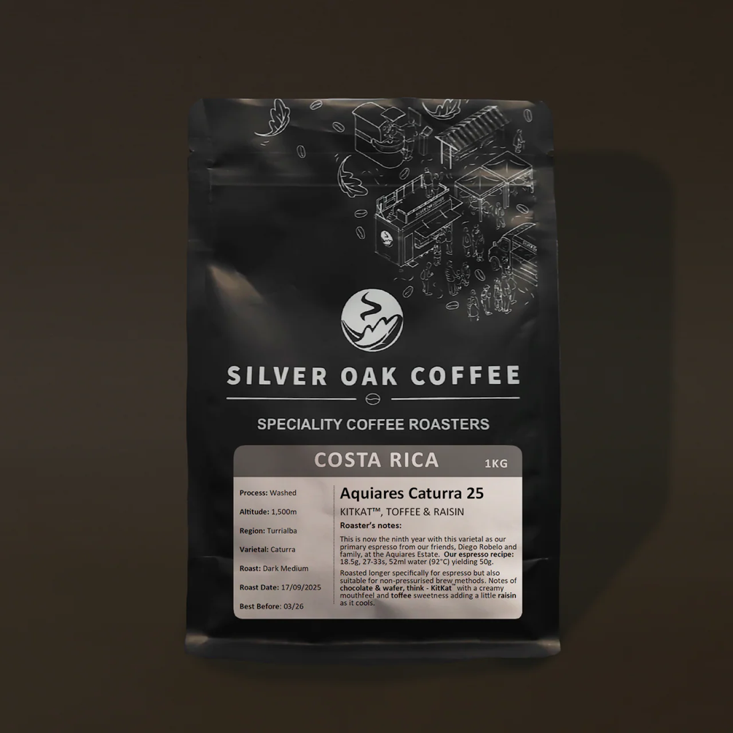

This is now the ninth year with our primary espresso from our friends, Diego Robelo and family, at the Aquiares Estate.
Roasted longer specifically for espresso but also suitable for non-pressurised brew methods.
Our espresso recipe: 18.5g, 27-33s, 52ml water (92°C) yielding 50g.

Cambridge Juice Company

Glebe Farm Pureoaty Barista Oat Milk
Nutritional Information
Per 100ml
- Energy 247 kJ 59 kcal
- Fat 1.8g Of which saturated 0.2g
- Carbohydrate 9.9g Of which Sugars 3.9g
- Fibre <0g
- Protein 1.1g
- Salt 0.1g
Ingredients
Water GLUTEN Free OATS (11% ) Sunflower Oil Salt

Glebe Farm Barista Almond Milk
Nutritional Information
- Energy 259 kJ 62 kcal
- Fat 1.8g Of which saturated 0.4g
- Carbohydrate 10.5g Of which Sugars 5.1g
- Fibre 0.5g
- Protein 0.8g
- Salt 0.1g
Ingredients:
Water, Almonds (4%), Maltodextrin (rice), Stabiliser (gellan gum), Natural Flavouring, Salt.
Nutritional Information Per 100ml
Energy 259 kJ
62 kcal
Fat 1.8g
of which saturates 0.4g
Carbohydrate 10.5g
of which sugars* 5.1g
Fibre 0.5g
Protein 0.8g
Salt 0.1g

Glebe Farm Barista Soya

Nutritional Information
- Energy 177 kJ 44 kcal
- Fat 1.5g Of which saturated 0.2g
- Carbohydrate 4.4g Of which Sugar 3.6g
- Fibre 0.6g
- Protein 3.0g
- Salt 0.1g
Ingredients:
Water, Dehulled Soya beans (7%), Sugar, Natural Flavouring, Stabiliser (Gellan Gum).
Nutritional Information Per 100ml
Energy 177 kJ
44 kcal
Fat 1.5g
of which saturates 0.2g
Carbohydrate 4.4g
of which sugars* 3.6g
Fibre 0.6g
Protein 3.0g
Salt 0.1g

Staff Allergen Awareness Declaration & Sign-Off
I confirm that I have read, understood, and agree to follow the Roost Coffee House Ingredients & Allergen Information Guide.
I understand that:
- I must not guess allergen or ingredient information
- I must always refer to the guide or a manager when responding to allergen queries
- Failure to follow allergen procedures may put customers at serious risk
I agree to follow allergen procedures at all times and to raise any concerns immediately.
Staff Name: _______________________________
Job Role: _______________________________
Signature: _______________________________
Date: _______________________________
Manager Signature: _______________________________

Staff Allergen Awareness Declaration & Sign-Off
I confirm that I have read, understood, and agree to follow the Roost Coffee House Ingredients & Allergen Information Guide.
I understand that:
- I must not guess allergen or ingredient information
- I must always refer to the guide or a manager when responding to allergen queries
- Failure to follow allergen procedures may put customers at serious risk
I agree to follow allergen procedures at all times and to raise any concerns immediately.
Staff Name: _______________________________
Job Role: _______________________________
Signature: _______________________________
Date: _______________________________
Manager Signature: _______________________________

Staff Allergen Awareness Declaration & Sign-Off
I confirm that I have read, understood, and agree to follow the Roost Coffee House Ingredients & Allergen Information Guide.
I understand that:
- I must not guess allergen or ingredient information
- I must always refer to the guide or a manager when responding to allergen queries
- Failure to follow allergen procedures may put customers at serious risk
I agree to follow allergen procedures at all times and to raise any concerns immediately.
Staff Name: _______________________________
Job Role: _______________________________
Signature: _______________________________
Date: _______________________________
Manager Signature: _______________________________

Staff Allergen Awareness Declaration & Sign-Off
I confirm that I have read, understood, and agree to follow the Roost Coffee House Ingredients & Allergen Information Guide.
I understand that:
- I must not guess allergen or ingredient information
- I must always refer to the guide or a manager when responding to allergen queries
- Failure to follow allergen procedures may put customers at serious risk
I agree to follow allergen procedures at all times and to raise any concerns immediately.
Staff Name: _______________________________
Job Role: _______________________________
Signature: _______________________________
Date: _______________________________
Manager Signature: _______________________________

Staff Allergen Awareness Declaration & Sign-Off
I confirm that I have read, understood, and agree to follow the Roost Coffee House Ingredients & Allergen Information Guide.
I understand that:
- I must not guess allergen or ingredient information
- I must always refer to the guide or a manager when responding to allergen queries
- Failure to follow allergen procedures may put customers at serious risk
I agree to follow allergen procedures at all times and to raise any concerns immediately.
Staff Name: _______________________________
Job Role: _______________________________
Signature: _______________________________
Date: _______________________________
Manager Signature: _______________________________

Staff Allergen Awareness Declaration & Sign-Off
I confirm that I have read, understood, and agree to follow the Roost Coffee House Ingredients & Allergen Information Guide.
I understand that:
- I must not guess allergen or ingredient information
- I must always refer to the guide or a manager when responding to allergen queries
- Failure to follow allergen procedures may put customers at serious risk
I agree to follow allergen procedures at all times and to raise any concerns immediately.
Staff Name: _______________________________
Job Role: _______________________________
Signature: _______________________________
Date: _______________________________
Manager Signature: _______________________________

Staff Allergen Awareness Declaration & Sign-Off
I confirm that I have read, understood, and agree to follow the Roost Coffee House Ingredients & Allergen Information Guide.
I understand that:
- I must not guess allergen or ingredient information
- I must always refer to the guide or a manager when responding to allergen queries
- Failure to follow allergen procedures may put customers at serious risk
I agree to follow allergen procedures at all times and to raise any concerns immediately.
Staff Name: _______________________________
Job Role: _______________________________
Signature: _______________________________
Date: _______________________________
Manager Signature: _______________________________

Staff Allergen Awareness Declaration & Sign-Off
I confirm that I have read, understood, and agree to follow the Roost Coffee House Ingredients & Allergen Information Guide.
I understand that:
- I must not guess allergen or ingredient information
- I must always refer to the guide or a manager when responding to allergen queries
- Failure to follow allergen procedures may put customers at serious risk
I agree to follow allergen procedures at all times and to raise any concerns immediately.
Staff Name: _______________________________
Job Role: _______________________________
Signature: _______________________________
Date: _______________________________
Manager Signature: _______________________________

