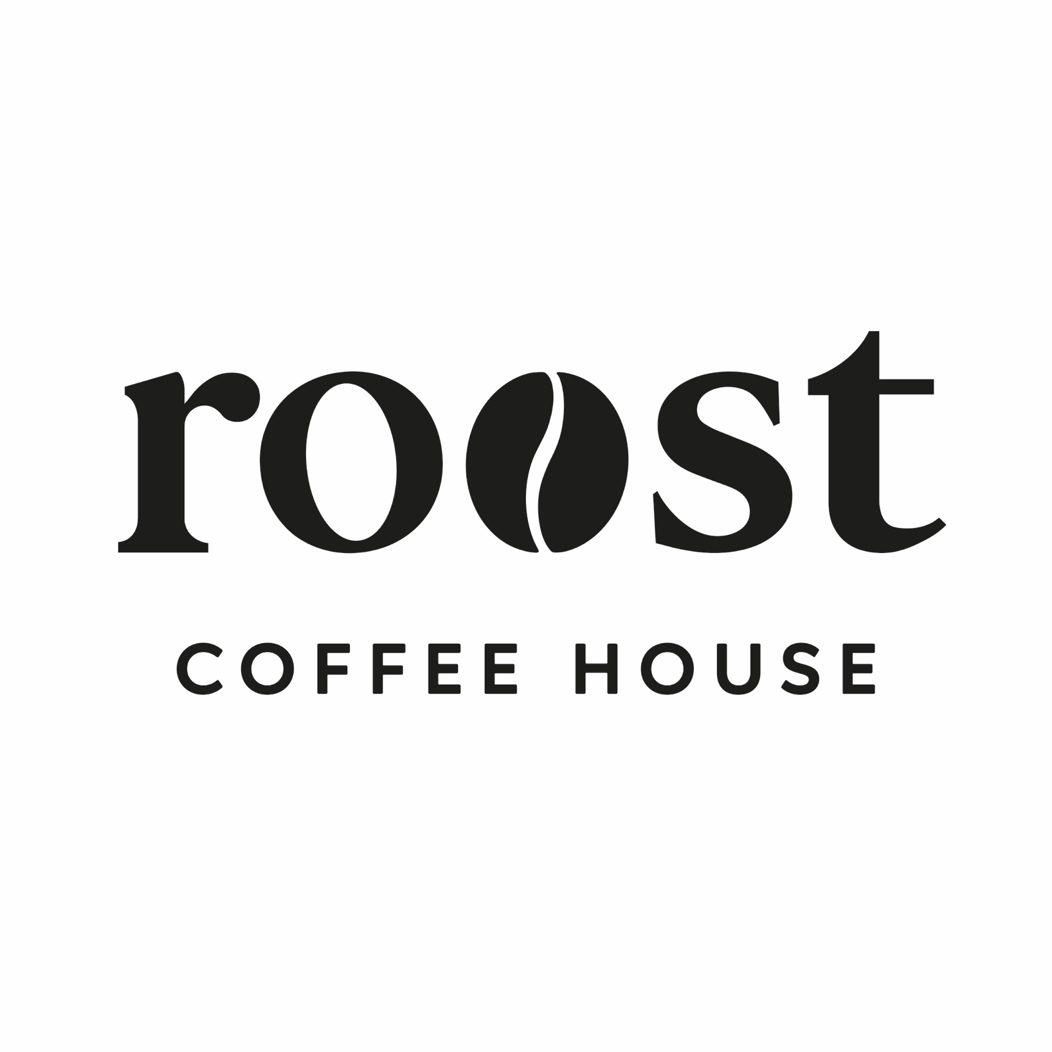

Supplier information, Ingredients and allergens
Contents

- About this guide – Page 3

- Supplier contact details – Page 4

- The Dessert Company – Pages 5-11

- Stir Bakery Page – Pages 12- 13

- Country Kitchen Page - 14

- Herbies – Page 15-16

- Silver Oak – Page 17

- Cambridge Juice Company - Page 18-19

- Bespoke Bakes - 20-23

- Staff declarations – Page 24 onwards

Ingredients & Allergen Information Guide
Staff Briefing & Usage Guidance
This guide has been produced to ensure Roost Coffee House meets its legal obligations under UK food safety and food information legislation and to protect customers with food allergies or intolerances. Allergens can cause serious, and sometimes life-threatening, reactions. Accurate communication of allergen information is therefore essential.

Purpose of This Guide
This document contains supplier information, ingredient lists, allergen identification (including the 14 legally recognised allergens), and “may contain” or cross-contamination details for food and drink served at Roost. It must be used by all staff involved in food preparation and customer service.

Legal Duty
Roost is legally required to provide clear, accurate, and consistent allergen information to customers.
Staff must:
- Never guess allergen or ingredient information
- Always refer to this guide when responding to customer queries
- Ensure information given to customers matches this document
If information cannot be confirmed, a manager must be consulted before responding.

Using This Guide
- Check this guide whenever a customer asks about ingredients or allergens
- Do not rely on memory or assumptions
- Escalate any uncertainty immediately
- Report any product, recipe, or supplier changes so the guide can be updated

Communication with Customers
All allergen queries must be taken seriously.
Staff should:
- Clarify allergies vs intolerances where appropriate
- Clearly explain any “may contain” or cross-contamination risks
- Never make guarantees unless confirmed in this guide

Cross-Contamination
Roost handles allergens within the premises. While procedures are in place to reduce risk, cross-contamination may occur. Any relevant risk information listed in this guide must be communicated to customers.

Staff Responsibility
All staff are responsible for understanding how to access and use this guide, completing allergen training, and escalating concerns when unsure. Customer safety is a shared responsibility.
Supplier contact details
The Dessert Company – Cakes and sweet treats
01223 235522
info@thedessertcompany.co.uk
www.thedessertcompany.co.uk
Fareacres Farm, Dry Drayton Road, Oakington, Cambs, CB24 3BD
Main point of contact – Mark Lawson

Stir Bakery – Pastries and bread
01223 869944
orders@stirbakery.co.uk
www.stirbakery.co.uk
Main point of contact – Clare

Country Kitchen – Sausage Rolls and Scotch Eggs
antoniailott@gmail.com
Main point of contact – Antonia ilott

Herbies American Diner – Cookies
01954 780001
Huntingdon Road, Swavesey, Cambridge, CB24 4RE
Paul.herbert11@btinternet.com
info@herbiesdiner.co.uk
Main point of contact – Paul and Claire

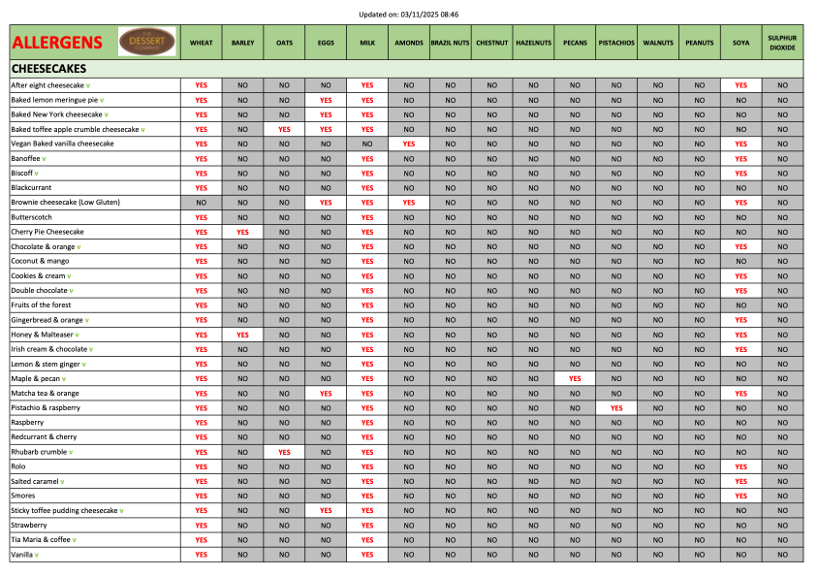

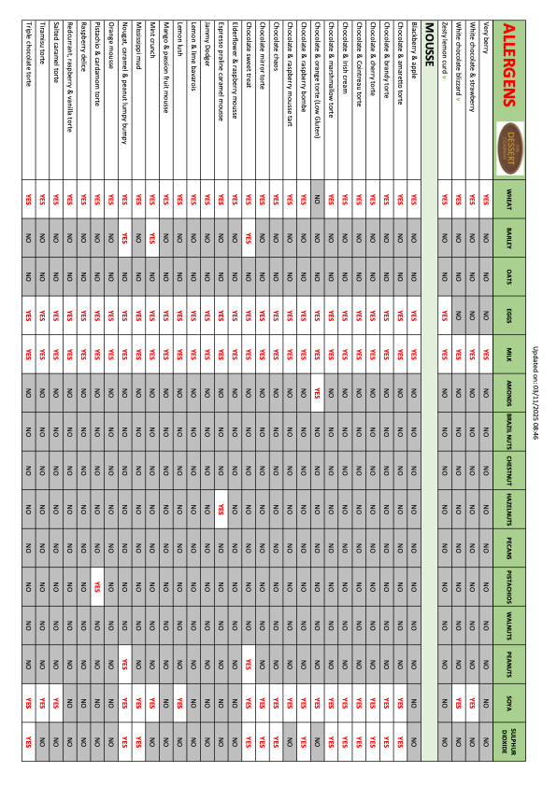
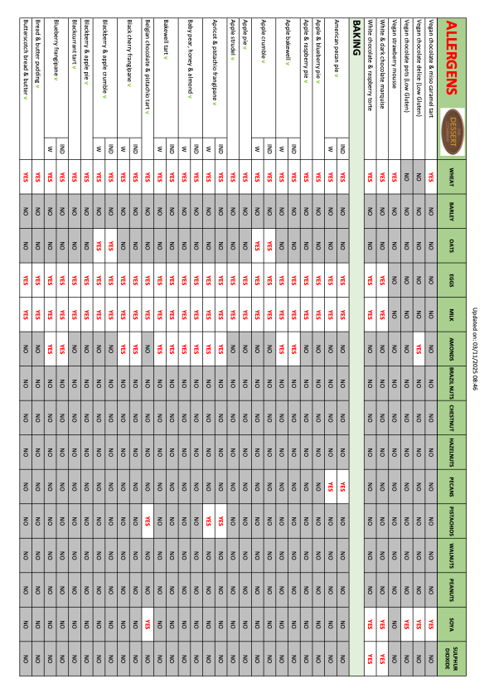

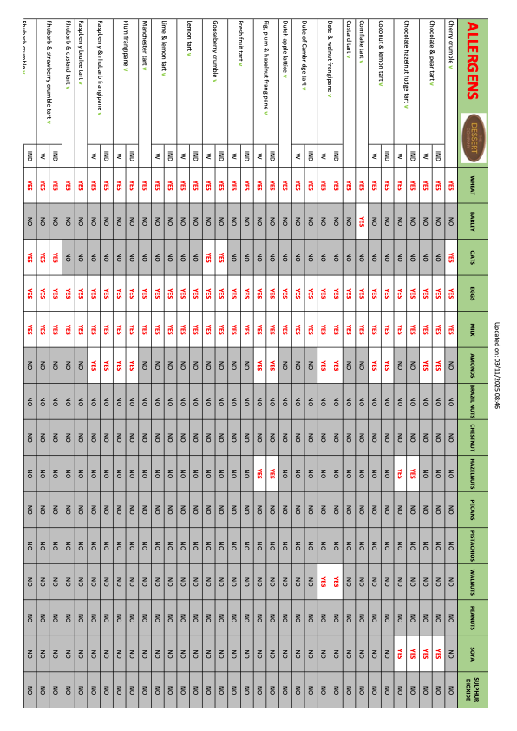
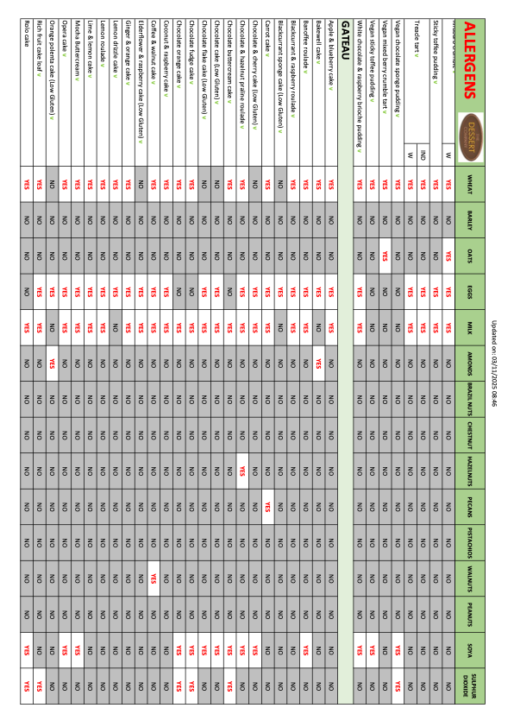
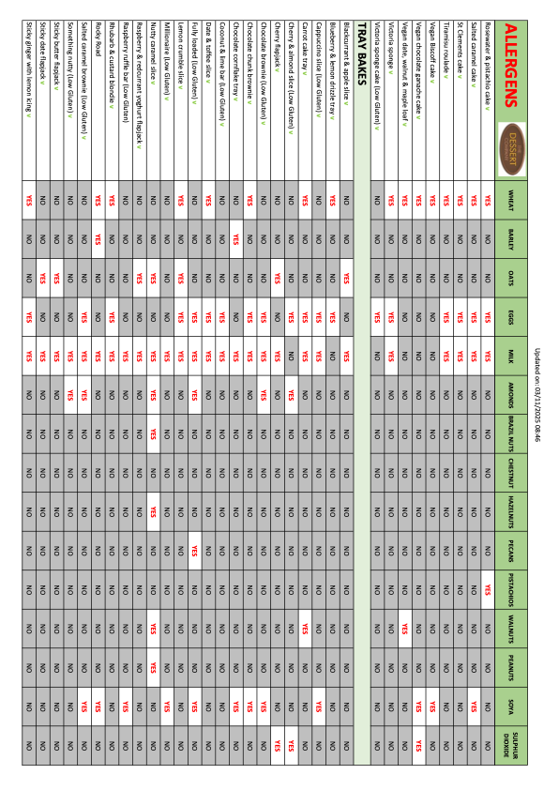
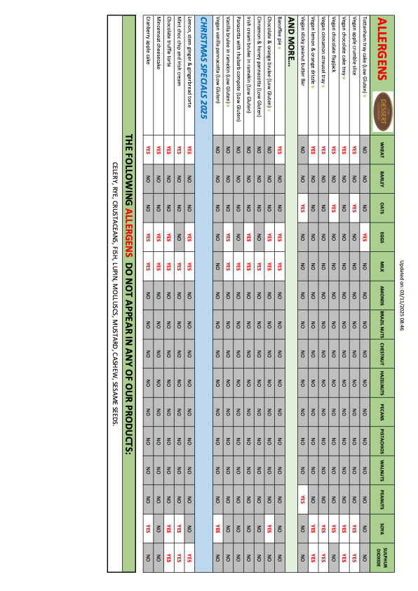

Stir Bakery

Pastries and Sweet Bakes
All Butter Croissant
Storage information – Store ambient on delivery day. Do not refrigerate.
Shelf life – Day of delivery only.
Ingredients – Wheat flour, butter (milk), water, yeast, sugar, salt.
Allergens – Wheat (gluten), milk.
May contain egg, soya, nuts, sesame.

Pain au Chocolat
Storage information – Store ambient on delivery day.
Shelf life – Day of delivery only.
Ingredients – Wheat flour, butter (milk), dark chocolate (cocoa mass, sugar, cocoa butter, soya lecithin), water, yeast, sugar, salt.
Allergens – Wheat (gluten), milk, soya.
May contain egg, nuts, sesame.

Pain Suisse
Storage information – Store ambient on delivery day.
Shelf life – Day of delivery only.
Ingredients – Wheat flour, butter (milk), custard (milk, egg, sugar, cornflour), chocolate, yeast, sugar, salt.
Allergens – Wheat (gluten), milk, egg, soya.
May contain nuts, sesame.

Spelt Banana Loaf Cake
Storage information – Store ambient in airtight container.
Shelf life – Up to 3 days from delivery.
Ingredients – Spelt flour (gluten), banana, egg, butter (milk), sugar, raising agents, spices.
Allergens – Spelt (gluten), egg, milk.
May contain nuts, soya.

Cinnamon Knots
Storage information – Store ambient on delivery day.
Shelf life – Day of delivery only.
Ingredients – Wheat flour, butter (milk), sugar, cinnamon, yeast, salt.
Allergens – Wheat (gluten), milk.
May contain egg, nuts, sesame, soya.

Fruit Scone
Storage information – Store ambient in airtight container.
Shelf life – Up to 2 days from delivery.
Ingredients – Wheat flour, butter (milk), milk, dried fruit (sultanas), sugar, raising agents.
Allergens – Wheat (gluten), milk. May contain egg, nuts.

Cheese Scone
Storage information – Store ambient in airtight container.
Shelf life – Up to 2 days from delivery.
Ingredients – Wheat flour, cheddar cheese (milk), butter (milk), milk, raising agents.
Allergens – Wheat (gluten), milk.
May contain egg, mustard.

BREAD

Spelt Sourdough
Storage information – Store ambient. Do not refrigerate.
Shelf life – Up to 3 days from delivery.
Ingredients – Spelt flour (gluten), water, salt, sourdough starter.
Allergens – Spelt (gluten).
May contain sesame.

Focaccia Round
Storage information – Store ambient.
Shelf life – Day of delivery + 1 day.
Ingredients – Wheat flour, water, olive oil, yeast, salt, rosemary.
Allergens – Wheat (gluten).
May contain sesame.

Ciabatta Loaf
Storage information – Store ambient.
Shelf life – Day of delivery + 1 day.
Ingredients – Wheat flour, water, yeast, salt, olive oil.
Allergens – Wheat (gluten).
May contain sesame.

Gluten Free Sourdough – Seeded
Storage information – Store ambient, slice and toast recommended after day one.
Shelf life – Up to 3 days from delivery.
Ingredients – Gluten-free flour blend (rice, maize), water, seeds (sunflower, pumpkin, linseed), sourdough starter, salt.
Allergens – Seeds.
Produced in a bakery handling gluten.

White & Wholemeal Sourdough
Storage information – Store ambient.
Shelf life – Up to 3 days from delivery.
Ingredients – Wheat flour (white & wholemeal), water, salt, sourdough starter.
Allergens – Wheat (gluten).
May contain sesame.

Seed & Grain Sourdough
Storage information – Store ambient.
Shelf life – Up to 3 days from delivery.
Ingredients – Wheat flour, water, mixed seeds & grains (sesame, sunflower, linseed), salt, sourdough starter.
Allergens – Wheat (gluten), sesame.
May contain nuts.

Country Kitchen
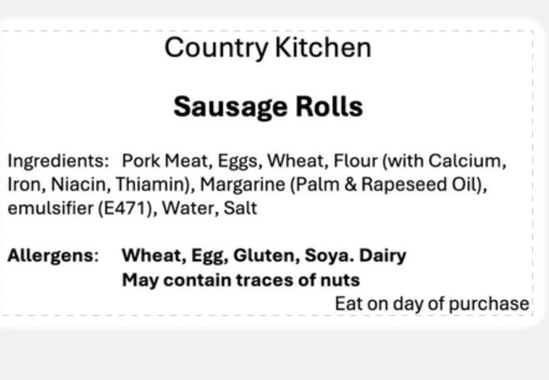

Sausage Roll

Storage information -

Shelf life – 5 days

Ingredients –

Allergens -
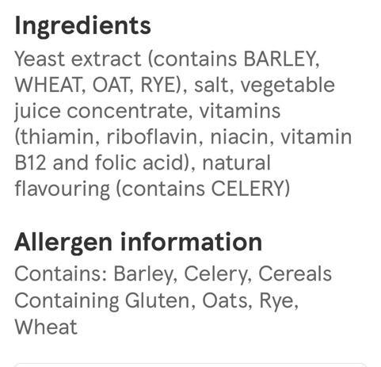
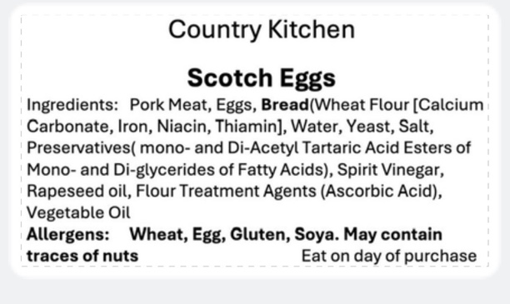

Scotch Egg

Storage information -

Shelf life – 5 days

Ingredients –

Allergens -

Brie & Bacon Sausage roll

Allergens: Gluten (Wheat), Milk, Egg, Soya

May contain: unless stated, all products may contain peanuts and tree nuts (cashew nuts and pine nuts)

Herbies Bakes

Please note: We use gluten, eggs, dairy, soya, sesame, tree nuts & peanuts in our kitchen. Our products may not be suitable for allergy sufferers.

Oreo stuffed NYC Cookie (UPDATED)
Baking butter: vegetable oils (rapeseed, palm), water, BUTTERMILK (7.5%), emulsifiers (sunflower lecithin, mono- & diglycerides of fatty acids) salt, natural flavouring (contain MILK) citric acid, vitamins (A,D), colour (carotenes). Light brown sugar (100% cane). Granulated white sugar (100% cane). EGGS. Vanilla essence: water, monopropylene glycol, colour (Caramel E150a), flavourings. Plain flour: (WHEAT flour, calcium, iron, niacin, nicotinamide, thiamin). Bicarbonate of soda: sodium hydrogen carbonate. Baking Powder: raising agents: diphosphates, sodium carbonates; rice flour. Milk Chocolate chunks: Sugar, whole (MILK) powder, cocoa butter, Cocoa mass, Whey powder (MILK) skimmed (MILK) powder, emulsifiers: (SOYA) lecithin, natural vanilla flavouring. Cookies & Cream spread: sugar,vegetable fat (palm), whole MILK powder, skimmed MILK powder, whey MILK powder, cocoa crumble (WHEAT flour, sugar vegetable oil (high oleic sunflower oil), cocoa powder, glucose-frutose syrup, raising agent (ammonium hydrogen carbonate, sodium hydrogen carbonate), salt, emulsifier (E-322), vanilla flavour), emulsifier (E-322 SOYA lecithin), cocoa butter, natural flavouring (MILK). White Chocolate spread: sugar, highly stable nob-hydrogenated palm oleic fat, skimmed MILK powder, dry WHEY (MILK) powder, fully hydrogenated fractionated palm kernel oil (lauric oil) based cocoa butter substitute (CBS), emulsifier E322 (sunflower lecithin), additives E492 sorbitan tristearate from vegetable fat, flavour (MILK). OREO Crumb: WHEAT flour, sugar, palm oil, rapeseed oil, fat reduced cocoa powder 4.5%, WHEAT starch, glucose fructose syrup, raising agents (ammonium carbonates, potassium carbonates, sodium carbonates), salt, emulsifier: (SOYA lecithins, sunflower lecithins), acidity regulator (sodium hydroxide), flavouring. May contain TREE NUTS & PEANUTS

Nutella stuffed Chocolate Chip NYC Cookie
Baking butter: vegetable oils (rapeseed, palm), water, BUTTERMILK (7.5%), emulsifiers (sunflower lecithin, mono- & diglycerides of fatty acids) salt, natural flavouring (contain MILK) citric acid, vitamins (A,D), colour (carotenes). Light brown sugar (100% cane). Granulated white sugar (100% cane). EGGS. Vanilla essence: water, monopropylene glycol, colour (Caramel E150a), flavourings. Plain flour: (WHEAT flour, calcium, iron, niacin, nicotinamide, thiamin). Bicarbonate of soda: sodium hydrogen carbonate. Baking Powder: raising agents: diphosphates, sodium carbonates; rice flour. Milk Chocolate chunks: Sugar, whole (MILK) powder, cocoa butter, Cocoa mass, Whey powder (MILK) skimmed (MILK) powder, emulsifiers: (SOYA) lecithin, natural vanilla flavouring. Nutella spread: sugar, palm oil, HAZELNUTS (13%), Skimmed MILK powder (8.7%), fat reduced cocoa (7.4%), emulsifier: lecithins (SOYA), vanillin. Milk Chocolate: sugar, cocoa butter, whole MILK powder, cocoa mass, emulsifier (E322 (SOYA)), vanilla extract. Chopped Nuts: PEANUTS (70%), ALMONDS & WALNUTS. May contain other TREE NUTS.

Traditional Rocky Road
Milk Chocolate: sugar, cocoa butter, whole MILK powder, cocoa mass, emulsifier (E322 (SOYA)), vanilla extract. Golden syrup: partially inverted refiners syrup. Baking butter: vegetable oils (rapeseed, palm), water, BUTTERMILK (7.5%), emulsifiers (sunflower lecithin, mono- & diglycerides of fatty acids) salt, natural flavouring (contain MILK) citric acid, vitamins (A,D), colour (carotenes). Digestive biscuits: Wheat flour (WHEAT flour, calcium carbonate, iron, niacin, thiamine) wholemeal WHEAT flour, sugar, palm oil, rapeseed oil, OATS, partially inverted refiners syrup, raising agents (sodium bicarbonate, ammonium) salt. Marshmallows: Corn glucose fructose syrup, sugar water, pork gelatine, anti-caking agent (corn starch), colour (beetroot red), flavouring. WHEAT flour (WHEAT flour, calcium carbonate, iron, niacin, thiamine) Rapeseed oil, sugar, butter (MILK), salt, natural flavouring, raising agent (sodium carbonates). Raisins (99.9%), sunflower oil). Glace cherries: cherry (56%), glucose-frutose syrup, sugar (18%), acidity regulator (citric acid), preservatives (potassium sorbate, SULPHUR DIOXIDE), colour (Erythrosine). Milk Chocolate Spread: sugar, highly stable non-hydrogenated palm oleic fat, dry WHEY powder, fat-reduced cocoa powder (6%), skimmed MILK powder, emulsifier; E322 (SOYA lecithin), flavour (MILK). Milk Chocolate: sugar, cocoa butter, whole MILK powder, cocoa mass, emulsifier (E322 (SOYA)), vanilla extract. May contain TREE NUTS & PEANUTS

Chunky Smarties Cookies (UPDATED)
Baking butter: vegetable oils (rapeseed, palm), water, BUTTERMILK (7.5%), emulsifiers (sunflower lecithin, mono- & diglycerides of fatty acids) salt, natural flavouring (contain MILK) citric acid, vitamins (A,D), colour (carotenes). Light brown sugar (100% cane). Granulated white sugar (100% cane). EGGS. Vanilla essence: water, monopropylene glycol, colour (Caramel E150a), flavourings. Plain flour: (WHEAT flour, calcium, iron, niacin, nicotinamide, thiamin). Bicarbonate of soda: sodium hydrogen carbonate. Baking Powder: raising agents: diphosphates, sodium carbonates; rice flour. Milk Chocolate chunks: Sugar, whole (MILK) powder, cocoa butter, Cocoa mass, Whey powder (MILK) skimmed (MILK) powder, emulsifiers: (SOYA) lecithin, natural vanilla flavouring. Mini Smarties: sugar, skimmed MILK powder, cocoa mass, cocoa butter, WHEAT flour, BUTTER oil, WHEY powder product, rice starch, emulsifier lecithins, colour (beetroot red,carotene, curcumin), spirulina concentrate, glazing agents (Caruba wax, beeswax white), vegetable concentrates (safflower, radish), BARLEY malt extract. Smarties: sugar, cocoa butter, skimmed MILK powder, cocoa mass, butterfat (from MILK), WHEAT flour, LACTOSE & proteins from whey (from MILK), rice starch, emulsifier: (lecithins), colours (beetroot red, carotene, curcumin), natural flavouring, spirulina concentrate, glazing agents (carnauba wax, beeswax white, fruit & vegetable concentrate (safflower, radish), BARLEY malt extract. May contain TREE NUTS & PEANUTS

Chunky Smarties Cookies (UPDATED)
Baking butter: vegetable oils (rapeseed, palm), water, BUTTERMILK (7.5%), emulsifiers (sunflower lecithin, mono- & diglycerides of fatty acids) salt, natural flavouring (contain MILK) citric acid, vitamins (A,D), colour (carotenes). Light brown sugar (100% cane). Granulated white sugar (100% cane). EGGS. Vanilla essence: water, monopropylene glycol, colour (Caramel E150a), flavourings. Plain flour: (WHEAT flour, calcium, iron, niacin, nicotinamide, thiamin). Bicarbonate of soda: sodium hydrogen carbonate. Baking Powder: raising agents: diphosphates, sodium carbonates; rice flour. Milk Chocolate chunks: Sugar, whole (MILK) powder, cocoa butter, Cocoa mass, Whey powder (MILK) skimmed (MILK) powder, emulsifiers: (SOYA) lecithin, natural vanilla flavouring. Mini Smarties: sugar, skimmed MILK powder, cocoa mass, cocoa butter, WHEAT flour, BUTTER oil, WHEY powder product, rice starch, emulsifier lecithins, colour (beetroot red,carotene, curcumin), spirulina concentrate, glazing agents (Caruba wax, beeswax white), vegetable concentrates (safflower, radish), BARLEY malt extract. Smarties: sugar, cocoa butter, skimmed MILK powder, cocoa mass, butterfat (from MILK), WHEAT flour, LACTOSE & proteins from whey (from MILK), rice starch, emulsifier: (lecithins), colours (beetroot red, carotene, curcumin), natural flavouring, spirulina concentrate, glazing agents (carnauba wax, beeswax white, fruit & vegetable concentrate (safflower, radish), BARLEY malt extract. May contain TREE NUTS & PEANUTS

Pistachio & white chocolate chunk stuffed NYC Cookie
Baking butter: vegetable oils (rapeseed, palm), water, BUTTERMILK (7.5%), emulsifiers (sunflower lecithin, mono- & diglycerides of fatty acids) salt, natural flavouring (contain MILK) citric acid, vitamins (A,D), colour (carotenes). Light brown sugar (100% cane). Granulated white sugar (100% cane). EGGS. Vanilla essence: water, monopropylene glycol, colour (Caramel E150a), flavourings. Plain flour: (WHEAT flour, calcium, iron, niacin, nicotinamide, thiamin). Bicarbonate of soda: sodium hydrogen carbonate. Baking Powder: raising agents: diphosphates, sodium carbonates; rice flour. White Chocolate Chunks: sugar, cocoa butter, whole MILK powder, LACTOSE, Whey powder (MILK), emulsifier (SOYA) lecithin. White Chocolate spread: sugar, highly stable nob-hydrogenated palm oleic fat, skimmed MILK powder, dry WHEY (MILK) powder, fully hydrogenated fractionated palm kernel oil (lauric oil) based cocoa butter substitute (CBS), emulsifier E322 (sunflower lecithin), additives E492 sorbitan tristearate from vegetable fat, flavour (MILK). White Chocolate: sugar, cocoa butter, whole MILK powder, emulsifier (E322 (SOYA)), vanilla extract. PISTACHIO NUTS (100%). Pistachio spread: PISTACHIOS (45%), sugar, oil (sunflower) & fats (palm & palm kernel), skimmed MILK powder, MILK WHEY powder, emulsifier: sunflower lecithin (E322), natural colourings (E100 – E141ii). May contain other TREE NUTS & PEANUTS

Triple Chocolate Brownies – Low Gluten
Baking butter: vegetable oils (rapeseed, palm), water, BUTTERMILK (7.5%), emulsifiers (sunflower lecithin, mono- & diglycerides of fatty acids) salt, natural flavouring (contain MILK) citric acid, vitamins (A,D), colour (carotenes). Dark chocolate: sugar, cocoa butter, cocoa mass, reduced fat cocoa powder, emulsifier (E322 (SOYA)), vanilla extract. EGGS. Caster sugar (100% cane). Gluten Free Flour: Flour Blend (Rice, Potato, Tapioca, Maize, Buckwheat). Cocoa powder: Cocoa powder, acidity regulator (potassium carbonates). Milk Chocolate chunks: Sugar, whole (MILK) powder, cocoa butter, Cocoa mass, Whey powder (MILK) skimmed (MILK) powder, emulsifiers: (SOYA) lecithin, natural vanilla flavouring. White Chocolate Chunks: sugar, cocoa butter, whole MILK powder, LACTOSE, Whey powder (MILK), emulsifier (SOYA) lecithin. Milk Chocolate: sugar, cocoa butter, whole MILK powder, cocoa mass, emulsifier (E322 (SOYA)), vanilla extract. White Chocolate: sugar, cocoa butter, whole MILK powder, emulsifier (E322 (SOYA)), vanilla extract. May contain TREE NUTS & PEANUTS

Millionaires Shortbread
Shortbread: Baking butter: vegetable oils (rapeseed, palm), water, BUTTERMILK (7.5%), emulsifiers (sunflower lecithin, mono- & diglycerides of fatty acids) salt, natural flavouring (contain MILK) citric acid, vitamins (A,D), colour (carotenes). Caster sugar (100% cane). Plain flour: (WHEAT flour, calcium, iron, nicotinamide, niacin, thiamin). Caramel: Butter: unsalted, min. 80% milk fat (MILK). Caster sugar (100% cane). Golden syrup: partially inverted refiners syrup. Sweetened condensed milk: contains a minimum of 8% milk fat & 20% milk solids not fat – whole cow MILK, sugar, skimmed MILK. Caramel: Butter: unsalted, min. 80% milk fat (MILK). Caster sugar (100% cane). Golden syrup: partially inverted refiners syrup. Sweetened condensed milk: contains a minimum of 8% milk fat & 20% milk solids not fat – whole cow MILK, sugar, skimmed MILK. Milk Chocolate: sugar, cocoa butter, whole MILK powder, cocoa mass, emulsifier (E322 (SOYA)), vanilla extract. Milk Chocolate Spread: sugar, highly stable non-hydrogenated palm oleic fat, dry WHEY powder, fat-reduced cocoa powder (6%), skimmed MILK powder, emulsifier; E322 (SOYA lecithin), flavour (MILK). White Chocolate: sugar, cocoa butter, whole MILK powder, emulsifier (E322 (SOYA)), vanilla extract. May contain TREE NUTS & PEANUTS

Silver Oak

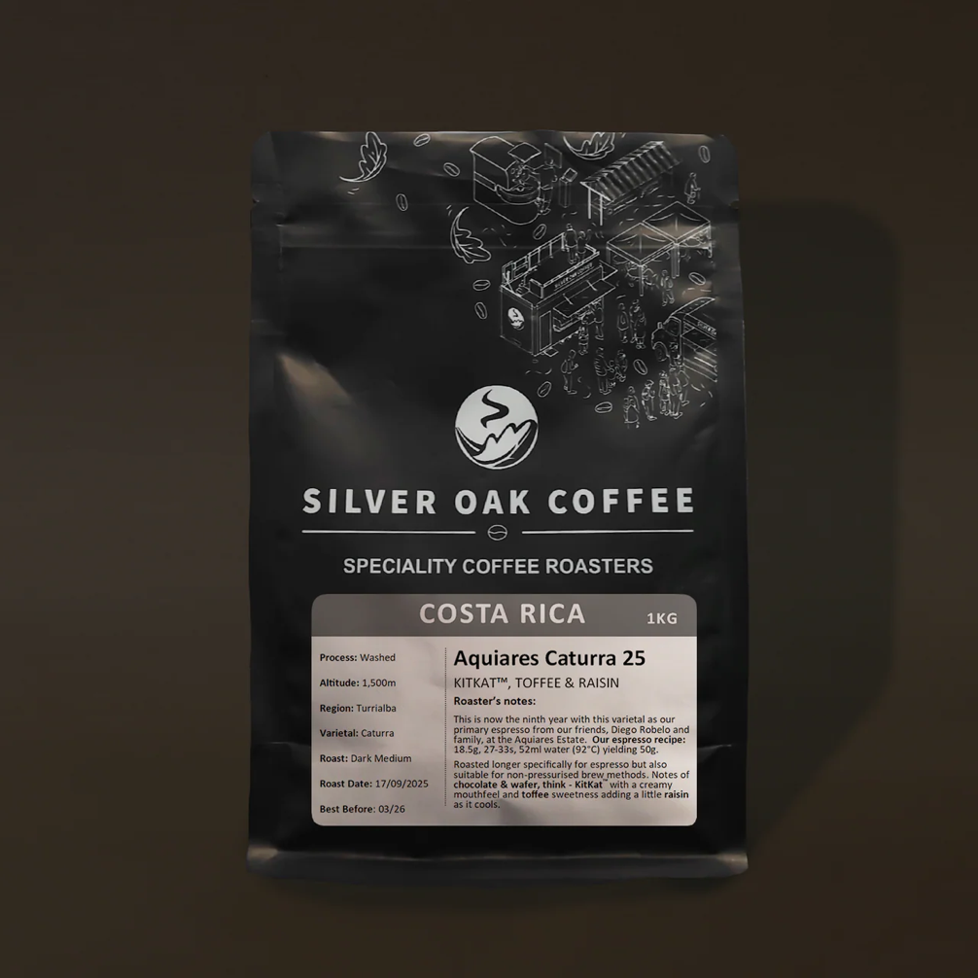

This is now the ninth year with our primary espresso from our friends, Diego Robelo and family, at the Aquiares Estate.
Roasted longer specifically for espresso but also suitable for non-pressurised brew methods.
Our espresso recipe: 18.5g, 27-33s, 52ml water (92°C) yielding 50g.

Cambridge Juice Company

Glebe Farm Pureoaty Barista Oat Milk
Nutritional Information
Per 100ml
- Energy 247 kJ 59 kcal
- Fat 1.8g Of which saturated 0.2g
- Carbohydrate 9.9g Of which Sugars 3.9g
- Fibre <0g
- Protein 1.1g
- Salt 0.1g
Ingredients
Water GLUTEN Free OATS (11% ) Sunflower Oil Salt

Glebe Farm Barista Almond Milk
Nutritional Information
- Energy 259 kJ 62 kcal
- Fat 1.8g Of which saturated 0.4g
- Carbohydrate 10.5g Of which Sugars 5.1g
- Fibre 0.5g
- Protein 0.8g
- Salt 0.1g
Ingredients:
Water, Almonds (4%), Maltodextrin (rice), Stabiliser (gellan gum), Natural Flavouring, Salt.
Nutritional Information Per 100ml
Energy 259 kJ
62 kcal
Fat 1.8g
of which saturates 0.4g
Carbohydrate 10.5g
of which sugars* 5.1g
Fibre 0.5g
Protein 0.8g
Salt 0.1g

Glebe Farm Barista Soya

Nutritional Information
- Energy 177 kJ 44 kcal
- Fat 1.5g Of which saturated 0.2g
- Carbohydrate 4.4g Of which Sugar 3.6g
- Fibre 0.6g
- Protein 3.0g
- Salt 0.1g
Ingredients:
Water, Dehulled Soya beans (7%), Sugar, Natural Flavouring, Stabiliser (Gellan Gum).
Nutritional Information Per 100ml
Energy 177 kJ
44 kcal
Fat 1.5g
of which saturates 0.2g
Carbohydrate 4.4g
of which sugars* 3.6g
Fibre 0.6g
Protein 3.0g
Salt 0.1g

Bespoke Bakes
Dishes and their allergen content
(Note – Please state the name of the cereal(s) containing gluten* and/or the name of the nut(s)†) All products are handled in a kitchen where nuts, gluten (wheat flour), soya, eggs and milk are present.

Dishes | Celery | Cereals containing gluten* | Crustaceans | Eggs | Fish | Lupin | Milk | Mollusc | Mustard | Nuts† | Peanuts | Sesame seeds | Soya | Sulphur Dioxide
Biscoff cookies |  | ✓Wheat flour |  | ✓ |  |  | ✓ |  |  |  |  |  | ✓
Kinder cookies |  | ✓Wheat flour |  | ✓ |  |  | ✓
White choc, macadamia, raspberry cookies |  | ✓Wheat flour |  | ✓ |  |  | ✓ |  |  | ✓Macadamia
Brown butter, salted caramel cookies |  | ✓Wheat flour |  | ✓ |  |  | ✓
Biscoff & Salted caramel cookie cup |  | ✓Wheat flour |  | ✓ |  |  | ✓ |  |  |  |  |  | ✓
Double choc cookie cup |  | ✓Wheat flour |  | ✓ |  |  | ✓
Classic brownie |  | ✓Wheat flour |  | ✓ |  |  | ✓
Triple choc brownie |  | ✓Wheat flour |  | ✓ |  |  | ✓
LG brownie |  |  |  | ✓ |  |  | ✓
Millionaires |  | ✓Wheat flour |  |  |  |  | ✓
LG millionaires |  |  |  |  |  |  | ✓
Hazelnut & salted caramel millionaires |  | ✓Wheat flour |  |  |  |  | ✓ |  |  | ✓Hazelnuts
Rocky road |  | ✓Wheat flour |  | ✓ |  |  | ✓ |  |  |  |  |  | ✓
Mini egg rocky road |  | ✓Wheat flour |  | ✓ |  |  | ✓ |  |  |  |  |  | ✓
Kinder cookies |  | ✓Wheat flour |  | ✓ |  |  | ✓ |  |  | ✓Hazelnuts |  |  | ✓
Biscoff & Salted caramel cookie cup |  | ✓Wheat flour |  | ✓ |  |  | ✓ |  |  |  |  |  | ✓
Millionaires |  | ✓Wheat flour |  |  |  |  | ✓ |  |  |  |  |  | ✓
Cornflake Brownie |  | ✓Wheat flour, Barley |  | ✓ |  |  | ✓ |  |  |  |  |  | ✓
Smarties cookie |  | ✓Wheat flour, Barley |  | ✓ |  |  | ✓ |  |  |  |  |  | ✓
Mars Brownie |  | ✓Wheat flour, Barley |  | ✓ |  |  | ✓ |  |  |  |  |  | ✓
Mars cookie brownie stack |  | ✓Wheat flour, Barley |  | ✓ |  |  | ✓ |  |  |  |  |  | ✓
Biscoff Brownie |  | ✓Wheat flour |  | ✓ |  |  | ✓ |  |  |  |  |  | ✓
Oreo Cookie |  | ✓Wheat flour |  | ✓ |  |  | ✓ |  |  |  |  |  | ✓
Salted Caramel Apple Cookie Slice |  | ✓Wheat flour |  | ✓ |  |  | ✓ |  |  |  |  |  | ✓

Review date:17/09/2026 |  | Reviewed by: | Amy Houghton |  |  |  | You can find this template, including more information at www.food.gov.uk/allergy-guidance

Product | Ingredients
Biscoff & Salted caramel Cookie cups | WHEAT FLOUR, light brown sugar, Butter (MILK), White chocolate (Sugar, cocoa butter, Whole MILK powder, emulsifier (SOYA lecithin) Natural vanilla flavouring), EGG, Biscoff spread (WHEAT FLOUR, sugar, vegetable oils (palm, rapeseed) candy sugar syrup, raising agent (sodium hydrogen carbonate) SOYA FLOUR, salt, cinnamon, rapeseed oil, sugar, emulsifier (SOYA lecithin) citric acid), Caramel (golden syrup, condensed milk (MILK), butter (MILK), sugar), cornflour, bicarbonate of soda, sea salt, Vanilla extract with seeds (water, vanilla extract, vanilla seeds, ethanol), sugar, inulin, thickener (tragacanth)
Millionaires’ shortbread | WHEAT FLOUR, sugar, Butter (MILK), Caramel (golden syrup, condensed milk (MILK), butter (MILK), sugar), Chocolate (Sugar, Whole MILK powder, Cocoa butter, cocoa mass, emulsifier lecithin (SOYA), Natural vanilla flavouring), Vanilla extract with seeds (water, vanilla extract, vanilla seeds, ethanol), sugar, inulin, thickener (tragacanth) CONTAINS: WHEAT, MILK, SOYA
Kinder cookies | WHEAT FLOUR, light brown sugar, Butter (MILK), Chocolate (Sugar, Whole MILK powder, Cocoa butter, cocoa mass, emulsifier lecithin (SOYA), Natural vanilla flavouring) HAZELNUT spread (sugar, palm oil, HAZELNUTS, fat reduced cocoa powder, dried skimmed milk (MILK), whey powder (MILK), lactose (MILK), emulsifier (sunflower lecithins) natural vanilla flavouring), Kinder bars (fine milk chocolate (MILK) (sugar, MILK powder, cocoa butter, cocoa mass, emulsifier :lecithin (SOYA), vanillin)sugar, skimmed MILK powder, palm oil, concentrated butter (MILK), emulsifier: lecithins (SOYA), vanillin, EGG, Vanilla extract with seeds (water, vanilla extract, vanilla seeds, ethanol), sugar, inulin, thickener (tragacanth)  CONTAINS: WHEAT, SOYA, EGG, MILK, HAZELNUTS
Cornflake Brownie | Sugar, Chocolate (cocoa mass, Sugar, cocoa butter, emulsifier lecithin (SOYA), Natural vanilla flavouring), butter (MILK), Cornflakes (Maize, sugar, salt, BARLEY malt extract, niacin, iron, pantothenic acid, vitamin B6, thiamin, riboflavin, folic acid, vitamin D, vitamin B12), Caramel (golden syrup, condensed milk (MILK), butter (MILK), sugar) EGG, WHEAT FLOUR, Cocoa powder (Acidity Regulator :501i, Citric acid), Vanilla extract with seeds (water, vanilla extract, vanilla seeds, ethanol), sugar, inulin, thickener (tragacanth) CONTAINS: WHEAT FLOUR, SOYA, BARLEY, EGG, MILK
Smarties cookie | WHEAT FLOUR, light brown sugar, Butter (MILK), Chocolate (Sugar, Whole MILK powder, Cocoa butter, cocoa mass, emulsifier lecithin (SOYA), Natural vanilla flavouring), smarties (sugar, skimmed milk powder (MILK), cocoa mass, glucose syrup, WHEAT FLOUR, whey powder product (MILK) butterfat (MILK), vegetable fats (palm, shea), starch, emulsifier (lecithins), colours (beetroot red, carotene, curcumin), flavourings, spirulina concentrate, glazing agents (carnauba wax, beeswax white), vegetable concentrates (safflower, radish), BARLEY malt extract), cornflour, EGG, Bicarbonate of soda, Vanilla extract with seeds (water, vanilla extract, vanilla seeds, ethanol), sugar, inulin, thickener (tragacanth) CONTAINS: MILK, SOYA, WHEAT, BARLEY, EGG
Salted Caramel Apple Cookie Slice | Sugar, Butter (MILK), Caramel (golden syrup, condensed milk (MILK), butter (MILK), sugar), WHEAT FLOUR, Chocolate (Sugar, Whole MILK powder, Cocoa butter, cocoa mass, emulsifier lecithin (SOYA), Natural vanilla flavouring), Apples, EGG, Bicarbonate of soda, Vanilla extract with seeds (water, vanilla extract, vanilla seeds, ethanol), sugar, inulin, thickener (tragacanth), Sea salt CONTAINS: WHEAT, EGG, MILK, SOYA
Mars Brownie | Sugar, Chocolate (cocoa mass, Sugar, cocoa butter, emulsifier lecithin (SOYA), Natural vanilla flavouring), butter (MILK), EGG, WHEAT FLOUR, Cocoa powder (Acidity Regulator :501i, Citric acid), Vanilla extract with seeds (water, vanilla extract, vanilla seeds, ethanol), sugar, inulin, thickener (tragacanth), Mars bars (Sugar, glucose syrup, skimmed MILK powder, cocoa butter, cocoa mass, sunflower oil, whey permeate (MILK), palm fat, MILK fat, fat-reduced cocoa powder, BARLEY malt extract, salt, emulsifier (SOYA lecithin), EGG white powder (MAY CONTAIN PEANUTS &amp; OTHER NUTS)) CONTAINS: WHEAT, SOYA, BARLEY, EGG, MILK
Biscoff Brownie | Chocolate (cocoa mass, Sugar, cocoa butter, emulsifier lecithin (SOYA), Natural vanilla flavouring), Sugar, Biscoff spread (WHEAT FLOUR, sugar, vegetable oils (palm, rapeseed) candy sugar syrup, raising agent (sodium hydrogen carbonate) SOYA FLOUR, salt, cinnamon, rapeseed oil, sugar, emulsifier (SOYA lecithin) citric acid), Caramelised biscuits (WHEAT FLOUR, sugar, palm oil, candy sugar syrup, rapeseed oil, raising agent: sodium carbonates, salt, ground cinnamon), butter (MILK), EGG, WHEAT FLOUR, Cocoa powder (Acidity Regulator :501i, Citric acid), Vanilla extract with seeds (water, vanilla extract, vanilla seeds, ethanol), sugar, inulin, thickener (tragacanth))  CONTAINS: WHEAT, SOYA, EGG, MILK
Mars cookie & Brownie stack | Sugar, Chocolate (cocoa mass, Sugar, cocoa butter, emulsifier lecithin (SOYA), Natural vanilla flavouring), butter (MILK), Mars bars (Sugar, glucose syrup, skimmed MILK powder, cocoa butter, cocoa mass, sunflower oil, whey permeate (MILK), palm fat, MILK fat, fat-reduced cocoa powder, BARLEY malt extract, salt, emulsifier (SOYA lecithin), EGG white powder (MAY CONTAIN PEANUTS &amp; OTHER NUTS)), Milk chocolate spread ( Sugar, vegetable oil (rapeseed, palm), Lactose (MILK), milk chocolate crumb (MILK, sugar, cocoa mass), full cream MILK powder, fat reduced cocoa, whey powder (MILK), emulsifier: lecithin,flavouring), EGG, WHEAT FLOUR, Cocoa powder (Acidity Regulator :501i, Citric acid), Vanilla extract with seeds (water, vanilla extract, vanilla seeds, ethanol), sugar, inulin, thickener (tragacanth) CONTAINS: WHEAT, SOYA, BARLEY, EGG, MILK
Oreo Cookie | WHEAT FLOUR, light brown sugar, Butter (MILK), Chocolate (Sugar, Whole MILK powder, Cocoa butter, cocoa mass, emulsifier lecithin (SOYA), Natural vanilla flavouring), Oreos (WHEAT flour, sugar, palm oil, rapeseed oil, WHEAT starch, fat reduced cocoa powder, glucose- fructose syrup, raising agent (ammonium carbonates, potassium carbonates, sodium carbonates), salt, emulsifier (SOYA lecithins), acidity regulator (sodium hydroxide), flavouring)), cornflour, EGG, Bicarbonate of soda, Vanilla extract with seeds (water, vanilla extract, vanilla seeds, ethanol), sugar, inulin, thickener (tragacanth) CONTAINS: MILK, SOYA, WHEAT, EGG

Staff Allergen Awareness Declaration & Sign-Off
I confirm that I have read, understood, and agree to follow the Roost Coffee House Ingredients & Allergen Information Guide.
I understand that:
- I must not guess allergen or ingredient information
- I must always refer to the guide or a manager when responding to allergen queries
- Failure to follow allergen procedures may put customers at serious risk
I agree to follow allergen procedures at all times and to raise any concerns immediately.
Staff Name: _______________________________
Job Role: _______________________________
Signature: _______________________________
Date: _______________________________
Manager Signature: _______________________________

Staff Allergen Awareness Declaration & Sign-Off
I confirm that I have read, understood, and agree to follow the Roost Coffee House Ingredients & Allergen Information Guide.
I understand that:
- I must not guess allergen or ingredient information
- I must always refer to the guide or a manager when responding to allergen queries
- Failure to follow allergen procedures may put customers at serious risk
I agree to follow allergen procedures at all times and to raise any concerns immediately.
Staff Name: _______________________________
Job Role: _______________________________
Signature: _______________________________
Date: _______________________________
Manager Signature: _______________________________

Staff Allergen Awareness Declaration & Sign-Off
I confirm that I have read, understood, and agree to follow the Roost Coffee House Ingredients & Allergen Information Guide.
I understand that:
- I must not guess allergen or ingredient information
- I must always refer to the guide or a manager when responding to allergen queries
- Failure to follow allergen procedures may put customers at serious risk
I agree to follow allergen procedures at all times and to raise any concerns immediately.
Staff Name: _______________________________
Job Role: _______________________________
Signature: _______________________________
Date: _______________________________
Manager Signature: _______________________________

Staff Allergen Awareness Declaration & Sign-Off
I confirm that I have read, understood, and agree to follow the Roost Coffee House Ingredients & Allergen Information Guide.
I understand that:
- I must not guess allergen or ingredient information
- I must always refer to the guide or a manager when responding to allergen queries
- Failure to follow allergen procedures may put customers at serious risk
I agree to follow allergen procedures at all times and to raise any concerns immediately.
Staff Name: _______________________________
Job Role: _______________________________
Signature: _______________________________
Date: _______________________________
Manager Signature: _______________________________

Staff Allergen Awareness Declaration & Sign-Off
I confirm that I have read, understood, and agree to follow the Roost Coffee House Ingredients & Allergen Information Guide.
I understand that:
- I must not guess allergen or ingredient information
- I must always refer to the guide or a manager when responding to allergen queries
- Failure to follow allergen procedures may put customers at serious risk
I agree to follow allergen procedures at all times and to raise any concerns immediately.
Staff Name: _______________________________
Job Role: _______________________________
Signature: _______________________________
Date: _______________________________
Manager Signature: _______________________________

Staff Allergen Awareness Declaration & Sign-Off
I confirm that I have read, understood, and agree to follow the Roost Coffee House Ingredients & Allergen Information Guide.
I understand that:
- I must not guess allergen or ingredient information
- I must always refer to the guide or a manager when responding to allergen queries
- Failure to follow allergen procedures may put customers at serious risk
I agree to follow allergen procedures at all times and to raise any concerns immediately.
Staff Name: _______________________________
Job Role: _______________________________
Signature: _______________________________
Date: _______________________________
Manager Signature: _______________________________

Staff Allergen Awareness Declaration & Sign-Off
I confirm that I have read, understood, and agree to follow the Roost Coffee House Ingredients & Allergen Information Guide.
I understand that:
- I must not guess allergen or ingredient information
- I must always refer to the guide or a manager when responding to allergen queries
- Failure to follow allergen procedures may put customers at serious risk
I agree to follow allergen procedures at all times and to raise any concerns immediately.
Staff Name: _______________________________
Job Role: _______________________________
Signature: _______________________________
Date: _______________________________
Manager Signature: _______________________________

Staff Allergen Awareness Declaration & Sign-Off
I confirm that I have read, understood, and agree to follow the Roost Coffee House Ingredients & Allergen Information Guide.
I understand that:
- I must not guess allergen or ingredient information
- I must always refer to the guide or a manager when responding to allergen queries
- Failure to follow allergen procedures may put customers at serious risk
I agree to follow allergen procedures at all times and to raise any concerns immediately.
Staff Name: _______________________________
Job Role: _______________________________
Signature: _______________________________
Date: _______________________________
Manager Signature: _______________________________

